Title of the Thesis

Association of Occupational Exposure to Silica Dust and COPD

Investigator
Dr. Md. Sadequr Rahman
Resident (phase-B), Internal Medicine
Sylhet MAG Osmani Medical College, Sylhet.

Guide
Prof.Dr.A.F.M. Nazmul Islam
Professor and Head
Department of Medicine
Sylhet MAG Osmani Medical College, Sylhet.

Co-Guide
Dr. Md. Enayet Hossain
Associate Professor
Department of Medicine
Sylhet MAG Osmani Medical College, Sylhet.

Dr. Md. Delwar Hossain
Assistant Professor
Department of Respiratory Medicine
Sylhet MAG Osmani Medical College, Sylhet.
INTRODUCTION
The Global Initiative for Chronic Obstructive Lung Disease (GOLD) has defined Chronic obstructive pulmonary disease (COPD) as a common, preventable and treatable disease that is characterized by persistent respiratory symptoms and airflow limitation that is due to airway and/or alveolar abnormalities usually caused by significant exposure to noxious particles or gases. Chronic airflow limitation is a characteristic of the COPD, which is caused by a mixture of small airways disease and parenchymal destruction the relative contributions of which vary from person to person (GOLD 2019). COPD includes emphysema and chronic bronchitis (Winberger, Cockrill, and Mandel 2014).
COPD is a global health concern and a major cause of chronic morbidity and mortality throughout the world. The Global Burden of Disease Study has projected that COPD, which ranked sixth as the cause of death in 1990, will become the third leading cause of death (Dhadke, Dhadke, and Raut 2015) and 5th common cause of morbidity all over the world by the year of 2020 (Helvaci, Aydin, and Aydin 2012).
The main risk factor for COPD is cigarette smoking. Other risk factors have also been implicated including exposure to industrial dust and fumes, outdoor air pollution (P. D. Blanc, Menezes, et al. 2009), second-hand smoke & biomass smoke (Blum et al. 2011). An estimated 15-30% of COPD cases are attributable to occupational exposures (Torén and Järvholm 2014).
Increased COPD risk has been associated with some specific occupational exposure agents, including: Silica (J. M. Dement et al. 2010; Tse et al. 2007), coal dust (Coggon and Newman Taylor, 1998), asbestos (J. M. Dement et al. 2010), Cement dust (Fell et al. 2010), diesel exhausts (Hart et al. 2009) etc.
Although tobacco smoking is the major risk factor for COPD, only 15–20% of smokers develop COPD (Barr et al. 2002; Mannino et al. 2002). A significant fraction of all COPD cases and COPD-related mortality occurs among nonsmokers (Eisner et al. 2010).
Crystalline silica is found in stone, rock, sand, gravel and clay, as well as products such as bricks, tiles, concrete, artificial stone benchtops and some plastic materials. When these materials are worked on, the silica is released as a fine dust. This dust is respirable crystalline silica commonly called silica dust (Carey et al. 2014).
It has been found that crystalline silica is more dangerous because of its needle like structure which is cytotoxic and produce highly reactive surface radicals after grinding which favours the adsorption of surface materials. The severity of diseases depends upon the size, shape, concentration of particles and duration of exposure (Iftikhar et al. 2009).
The air of quarry area is composed of abundant particulate substance of silica dust. The workers of stone quarry are exposed to silica dust of different concentration and particulate size. Average dust levels vary from about 0.04mg/m3 to over 5mg/m3. A study suggested that loss of lung function occurs with exposures to silica dust at concentration of between 0.1 and 0.2mg/m3 (Rushton 2007). Moreover, inhalation of silica dust for long periods can causes focal and interstitial fibrosis, centrilobular emphysema and progressive massive fibrosis of lungs (Ralston et al. 2018). It is also found that workers exposed to silica have an increased risk of chronic bronchitis because of non-specific effects of dust (Seaton, Seaton, and Leitch 2008).
People with COPD suffering from chronic respiratory symptoms such as cough, sputum production and shortness of breath. They may also experience more systemic symptoms such as fatigue, weight loss, muscle weakness and anorexia. Depression and anxiety are also common factors that contribute to comorbidity (Ralston et al. 2018).
The most widely recommended diagnostic criteria for COPD used in clinical practice requires the presence of relevant symptoms and a compatible clinical history (history of smoking or other noxious exposures) together with objective measures of airflow obstruction as defined by a post-bronchodilator forced expiratory volume in one second (FEV1) to forced vital capacity (FVC) ratio of less than 0.7 (Benfield, Lange, and Vestbo 2008).
A study was conducted in Peshawar, Pakistan on 160 workers of dust generating industries having exposure to silica dust for 5 years or more. The result showed, 56 (35%) people were suffering from COPD among them 48 were smoker and 8 were non-smoker exposure (Iftikhar et al. 2009). Another study was conducted in Wales, UK. In that study, 1255 men participated and among them 726 were slate miners expose to respirable crystalline silica and 529 were unexposed non miners. The study also showed COPD was more common in miners, n=213 (33%), than non-miners, n=120, (26%). After adjustment for smoking status, slate miners were associated with reduction of FEV1 and FVC and increase risk of COPD which is independent of the smoking status (Reynolds et al. 2017).
Stone quarry is one of the industries in Bangladesh that make the workers more prone to silica exposure. There are more than eight hundred stone quarries in Sylhet region, mainly distributed in Bholaganj of Companiganj upazilla and Jaflong of Gowainghat upazilla which roughly employ more than one lac workers. But even with such large number of employees, stone quarrying remains an unorganized sector of industry.
Because quarry industry has become one of the major employers of labour in Bholaganj and Jaflong, this study aims to determine the association of occupational exposure to silica dust with COPD among stone quarry workers in that areas. This study will also document the availability of health care facilities and safety measures at the site as ways of minimizing occupational health hazards associated with stone quarrying.
Rationale of the study
Rapid industrialization, requiring heavy supplies of construction material like stones, bricks, cement producing silica dust in health endangering amounts. Cigarette smoking, lack of protective measures against silica dust inhalation and long hours of daily exposure are all adding significantly to the problem.
The workplace health hazards are an important public health issue and are avoidable through preventable intervention in the workplace. Although the developed nations have taken few steps forward to ensure safe and healthful working conditions by setting and enforcing standards, Bangladesh is still lagging behind.
Even though stone quarry industry has been the main way of earning livelihood for thousands of people in Sylhet. This occupation quite understandably posing and has health risks for the employees who is working there. Silica dust, being the most abundant particulate substance in the air of quarry areas, is likely to causing the COPD.
Therefore, the purpose of this study is to ascertain the association between prolonged exposure to silica dust and COPD among the stone quarry workers in Sylhet. The findings of this study will be beneficial in policy making and enforcing proper legislative measures, so that the health hazards of the quarry workers can be minimized in the future.
Research Question
- Is silica dust associated with COPD irrespective of smoking?
Hypothesis
- COPD can be caused by silica dust only irrespective of smoking.
- Silica dust act synergistically with smoking causing the chronic obstructive pulmonary diseases (COPD).
Objectives
General Objective:
To see the association between silica dust exposure and COPD among the stone quarry workers in Sylhet.
Specific Objectives:
To establish the diagnosis of COPD by compatible history and spirometry.
To see the prevalence of COPD among the nonsmokers exposed to silica dust.
To see the prevalence of COPD among the smokers exposed to silica dust.
To assess the severity of COPD by GOLD severity scale 2008.
To see the association between silica dust exposure and COPD.

LITERATURE REVIEW
The main purpose of this section is to present a resume of conceptual frame work relating to ascertain the association between occupational exposure to silica dust and Chronic obstructive pulmonary disease (COPD) among the stone quarry workers in Sylhet. Past studies give a way to future work and help to better understanding of the research problem and to develop a suitable research method. The relevant studies and their findings are limited, which are related to Sylhet region. However, an attempt is made to orient much on the theoretical views of different authors/scientists on the subject and closely related results are reported. Keeping in view the subject of the study, the review of the available literature related to the study are presented under the following discussion.
An Overview of COPD
Chronic Obstructive Pulmonary Disease (COPD) is a global health concern and a major cause of chronic morbidity and mortality worldwide. Chronic obstructive pulmonary disease (COPD) is characterized by persistent airflow limitation that is usually progressive and associated with a chronic inflammatory response in the airways and lungs to noxious particles or gases. The persistent airflow limitation results from a combination of diffuse small airway disease and destruction of the lung parenchyma (emphysema). Chronic bronchitis (defined as cough and phlegm for at least 3 months per year in 2 consecutive years) may precede or coincide with airway narrowing but may also be seen in patients without COPD (Soriano and Rodríguez-Roisin 2011).
The American Thoracic Society (ATS) deﬁnes COPD as a “disease state characterized by the presence of airﬂow obstruction due to chronic bronchitis or emphysema”. The European Respiratory Society (ERS) deﬁnition of COPD is based on progressive and irreversible reduction of maximum expiratory ﬂow (E. Hnizdo and Vallyathan 2003).
COPD is a large, growing public health problem. According to the World Health Organization, its expected burden will increase in the coming decades, mostly due to continued exposure to risk factors, population growth and aging, to become the third leading cause of death by 2030 (Blanco et al. 2018).
According to the World Health Organization, it is currently the sixth leading cause of death in the world, and further increases in the prevalence and mortality of the disease is predicted for the coming decades (Aït-Khaled, Enarson, and Bousquet 2001). These increases are mainly linked to the epidemic of tobacco exposure and indoor and outdoor air pollution. The burden of COPD in Asia is currently greater than that in the developed western countries, both in terms of total number of deaths and the burden of disease, as measured in years of life lost and years spent living with disability (Tan and Ng 2008).
COPD is a name coined for the diseases that were previously known as chronic bronchitis and emphysema. The American Thoracic Society (ATS) defines COPD as a “disease state characterized by the presence of airflow obstruction due to chronic bronchitis or emphysema” (Celli et al. 1995).
The British Medical Research Council (BMRC) defined chronic bronchitis as “daily productive cough for at least three consecutive months for more than two successive years (Definition and classification of chronic bronchitis for clinical and epidemiological purposes. A report to the Medical Research Council by their Committee on the Aetiology of Chronic Bronchitis. 1965). Chronic bronchitis, with an obstructive ventilatory pattern that is defined by the existence of chronic bronchitis with permanent obstruction of airways (forced expiratory volume in 1 s (FEV1) to forced vital capacity (FVC) ratio <70%) (Raherison and Girodet 2009).
American Thoracic Society (ATS) in 1962 defined emphysema as an “anatomic alteration of the lung characterized by an abnormal enlargement of the air spaces distal to the terminal, non-respiratory bronchiole, accompanied by destructive changes of the alveolar walls” (Fletcher and Pride 1984). Centrilobular emphysema is a result of the dilation or destruction of respiratory bronchioles. It is a form of emphysema associated with cigarette smoking. Pan lobular emphysema is more often associated with a deficit in α₁-antitrypsin and is the result of dilation or destruction of all the lobules. It should be noted that centrilobular and pan lobular emphysema can be mutually associated (Raherison and Girodet 2009).
Reid (1967) reported that “the diagnosis of emphysema by itself is incomplete unless it is taken into account the presence or absence of chronic bronchitis and vice versa”. Mitzner (2011) have recently reported that extensive obliteration of terminal bronchioles in patients with COPD who have emphysema, suggesting that “the permanent enlargement of the distal airspaces may serve only as a structural biomarker, being a secondary result of small airway inflammation and destruction”.
Incidence and Prevalence of COPD
Existing COPD prevalence data vary widely due to differences in survey methods, diagnostic criteria, and analytical approaches. Importantly, all the studies defined COPD by spirometry alone and not by the combination of symptoms and spirometry. The lowest estimates of prevalence are those based on self-reporting of a doctor’s diagnosis of COPD, or equivalent condition. For example, most national data show that <6% of the adult population have been told that they have COPD. This is likely to be a reflection of the widespread under-recognition and under-diagnosis of COPD (GOLD 2019).
World Scenario
COPD is an increasing disease in both developed and developing countries (Govender, Lalloo, and Naidoo 2011). According to estimated data from the Global Burden of Disease Study, more than 300 million people in 2013 were suffering from the COPD (Vos et al. 2015).
The overall COPD prevalence among US adults aged 40–79 years varied from 0.2% to 20.9% based on whether pre- or post-bronchodilator values were used and which diagnostic criterion was applied (Tilert et al. 2013).
In European adult populations, over 40 years, the prevalence of COPD ranges between 15–20% and is higher in men than in women (Atsou, Chouaid, and Hejblum 2011). For example, the overall prevalence of COPD in the Netherlands is 3.0% (Afonso et al. 2011), in Denmark, it is 17.4% (Fabricius et al. 2011). In addition, in Spain, the COPD prevalence is 7.3% as found by Cabrera López et al., (2014) and 10% as found by Gómez Sáenz et al., (2014). Cazzola et al., (2011) conducted a research based on national medical in Italy, reported that, COPD prevalence at 2.8%.
According to Tageldin et al., (2012) COPD prevalence in the Middle East and North Africa is 3.6%. The pooled COPD prevalence defined by GOLD criteria at Latin America and the Caribbean is 13.4% (Ciapponi et al. 2014). A Meta-analysis of five spirometry-based studies from Africa reported a mean prevalence of COPD as 13.4%, ranging from 9.4 to 22.1% (Adeloye et al. 2015). Another Meta-analysis of nine studies from Sub-Saharan Africa reported a prevalence ranging from 4 to 25% (Finney et al. 2013). In 2012, a study done in rural Uganda reported a COPD prevalence of 16.2% in people older than age 30 years. Higher prevalence among people aged 30–39 years was reported in this study which is made by Van Gemert et al., (2015). Furthermore, COPD prevalence among adults aged 40–80 years in Abu Dhabi was reported at 3.7% (Al Zaabi et al. 2011).
The reported prevalence of COPD ranged from 0.2% in Japan to 37% in the USA, but this varied widely across countries and populations both by the diagnosis method and by the age group analysed (Rycroft et al. 2012).
Bangladesh Scenario
Peter J. Barnes, (2012) claimed that more than 90% of COPD deaths occur in low and middle-income countries. In Bangladesh, limited data are available on COPD. Since 2000, several studies have been conducted in Bangladesh to identify the burden and risk factors of COPD. Sutradhar et al 2019 conducted his study in terms of methodology (hospital-based and population-based study), sample size, and area of the study (urban/rural). Furthermore, different criteria were used to measure the COPD status in these studies. However, no systematic review has been carried out in Bangladesh to provide a clear scenario of COPD burden and risk factors in this country. Therefore, they carried out this systematic review with the aim to find out the prevalence of COPD and its associated risk factors among the Bangladeshi population (Sutradhar et al. 2019).
A large cluster study, [Burden of Obstructive Lung Disease (BOLD)] found that the population prevalence of COPD among people greater than 40 years and older is 21.6% and overall prevalence in general population is 4.32%. The disease hits hardest those who are still in the productive phase of life (42% of COPD between 40 and 50 years) (R. R. Biswas and Chowdhury 2017). According to high-quality studies that used the GOLD criteria, the pooled COPD prevalence among Bangladeshi adults was 12.5% (95% CI, 10.9-14.1) ranging between 11.4% (95% CI, 9.3-13.5), which was found among participants aged 35 years or more, and 13.5% (95% CI, 12.4–14.6), which was reported among participants aged 40 years or above (Alam et al. 2015).
Two moderate-quality studies were carried out on two specific groups of population: (a) R. S. R. Biswas et al., (2016) conducted a study on women of rural Chittagong exposed to fuel smoke and (b) helpers of human haulers of Dhaka city (Mahfuz et al. 2014). Remarkably, the prevalence of COPD was found much higher in these two groups of people (women exposed to fuel smoke: 20.4%; helpers of human haulers: 41.7%).
According to the high-quality studies, the prevalence of COPD was greater among males and ranged from 11.7% to 22.0% compared to females (range: 6.4% to 10.6%). These two studies also reported that COPD was more prevalent among the low socio-economic groups (13.6% to 16.3%) than the high socio-economic groups (9.8% to 11.1%). Interestingly, Alam et al., (2015) found that the mean age of COPD patients was higher than that of the non-COPD patients (COPD: 57 years; non-COPD: 44 years). A high-quality study conducted by Islam et al., (2013) reported that COPD was more prevalent among rural people (17.0%) than their urban counterparts (9.9%).
The pooled prevalence of COPD among people in the 40-49 years age group was 7.5% (range: 5.2% to 9.8%). On the other hand, this prevalence was 21.5% (range: 13.6% to 29.4%) among 50-59 years age group and 39.3% (27.5% to 51.0%) among people of 60-69 years age group (Alam et al. 2015; R. S. R. Biswas et al. 2016). Islam et al., (2013) reported that the prevalence of COPD was also higher among biomass fuel users and ranged from 16.4% to 17.3% compared to clean fuel (e.g. LP gas or natural gas) users (range: 4.4% to 10.0%). Based on peak expiratory flow rate (PEFR)%, severe bronchial obstruction was also found higher among biomass fuel users (55.4 %) than gas users (29.1%) (Alim et al. 2014).
Saroar Hosan et al (2017) is clearly seen that most of the COPD patient are male. The Ratio of COPD patient Male: Female almost 4:1. The prevalence of COPD according to patient’s age are higher in larger age group and it’s about to 35%. They also found that most of the COPD patients are smoker and most of them having smoking experience at least 10 years or above.
According to a study known as BOLD-BD (Burden of obstructed lung disease in Bangladesh), on COPD conducted by Bangladesh lung foundation, Burden of COPD in Bangladeshis are as follows:
- Prevalence in >40 years of age is 21.24%
- Prevalence in general population is 4.3%
- Total burden of COPD patients is about 6 million.
Pathogenesis of COPD:
Chronic obstructive pulmonary disease (COPD) is a heterogeneous disease characterized by persistent respiratory symptoms and irreversible airflow limitation. It has become the fourth leading cause of death (Lozano et al. 2012) and in the coming decades, further increases in COPD morbidity and mortality are expected (C. Wang et al. 2018) Epidemiological data has proved that cigarette smoking is the most common risk factor for COPD development and progression throughout the world. The airway epithelium is the first line of defence against noxious particles or gases entering the lungs. Increasing evidence has demonstrated that airway epithelial cell dysfunction plays a critical role in COPD pathogenesis(Hiemstra, McCray, and Bals 2015).
Chronic obstructive pulmonary disease (COPD) is a progressive, obstructive disease of the lungs, and it becomes the third leading cause of death worldwide (S. I. Rennard and Drummond 2015). The pathology of this disease is characterized by abnormal inflammatory responses, mucus hypersecretion, airway obstruction and remodelling, as well as alveolar destruction (Mirza et al. 2018). Cigarette smoke (CS) is a major risk factor for the development of COPD, which accounts for at least 75% of COPD deaths. CS contains thousands of chemicals, which contact with lung epithelial cells and damage them directly. This leads to cascade responses, including oxidative stress, protease/antiprotease imbalance, inflammation, apoptosis, and senescence, thereby causing lung injury (Yue and Yao 2016). In addition to the epithelial cells, endothelial cells (ECs) are also effector cells during CS-induced emphysema, as the volatile components in CS, such as aldehyde and acrolein, can directly enter into the blood vessels, causing EC injury (Lerner, Sundar, and Rahman 2016). In fact, EC apoptosis is one of the contributing factors to the development of pulmonary emphysema (García-Lucio et al. 2018). However, the mechanisms underlying CS-induced EC apoptosis are not fully understood.
Previous studies have shown that glucose, fatty acids, and glutamine metabolism are abnormal in patients with COPD (Telenga et al. 2014). These studies employed metabolomics, lipidomics, and metabolic flux to determine fuel metabolism using sputum, blood, and urine samples from patients with COPD.
These approaches provide advanced technology to detect a complete picture of the metabolic phenotype from COPD patients. For example, glucose production, clearance, and oxidation, and rate of glycolysis were increased in patients with COPD compared with control subjects. However, there is no change in the rate of nonoxidative disposal of pyruvate or serum lactate between healthy controls and COPD patients. Lipid metabolism was dysregulated during the onset of COPD. Glycerophospholipid and sphingolipid metabolism were associated with worse airflow obstruction, lung function decline, and COPD exacerbations (Cruickshank-Quinn et al. 2018). Compared to healthy controls, COPD patients displayed decreased lipoprotein and amino acids in serum and urine (Wang et al., 2013), including branched-chain amino acids, and increased glycerol phosphocholine in serum. Nevertheless, the cell-specific metabolic alterations in COPD remain elusive. CS exposure has been shown to reduce glycolysis in type II cells (Agarwal, Yin, and Cadenas 2014).
Chronic obstructive pulmonary disease (COPD) is a chronic progressive lung disease characterised by progressive and non-reversible airway obstruction with systemic manifestations and major comorbidities affecting patients’ quality of life (Kim and Criner 2013). COPD is currently the fourth most common cause of death worldwide and expected to be the third by 2030 if preventive measures are not taken (McGuinness and Sapey 2017). Cigarette smoking (CS) is by far the most common cause of COPD (Kirkham and Barnes 2013). The World Health Organization estimates that up to 73% of COPD deaths in high-income countries and over 90% in developing countries are related to tobacco smoking. Other factors such as environmental pollution, exposure to biomass smoke and genetic factors have been reported to be involved in the development of the disease (Bernardo, Bozinovski, and Vlahos 2015).
Disease onset occurs most often in people over 40 years of age and elderly populations that have a personal history of smoking. However, although about 90% of COPD are smokers, only 15–20% of chronic smokers (rising to 50% in heavy smokers) will develop clinically relevant COPD so it is extremely important to identify who is at highest risk and why. In addition, current therapies for COPD are largely ineffective and the development of new treatments for the disease have been hindered because the basic mechanisms that lead to COPD initiation and progression are poorly understood (McGuinness and Sapey 2017).
The pathophysiology of COPD is associated with obstruction of the smaller airways and tissue remodelling that occurs because of chronic inflammation and destruction of the lung parenchyma in response to various environmental (CS among others) and genetic stimuli. Despite public information campaigns by governments and medical societies to prevent and quit smoking, one-fifth of the population continues to smoke, and in each puff, 1015 oxidants and more than 4000 chemical compounds are inhaled (Van Eeden and Sin 2013). [Numerous evidences over the years have shown that oxidative stress, a condition in which the amount of oxidizing molecules overwhelms cellular antioxidant defences, and the associated oxidative damage to biomolecules located in the cells of the airways play an important role in the pathogenesis of COPD (Van Eeden and Sin 2013). Importantly, oxidative stress and oxidative damage persist in the airways of COPD patients after smoking cessation (Louhelainen et al. 2009). The sources of oxidizing substances responsible for the development of oxidative stress are numerous and varied and include oxidants derived from environmental pollution (nanoparticles from industries, car exhaust fumes, etc.) and cigarette smoke and endogenous substances released by leukocytes and macrophages involved in the chronic inflammation process observed in the lungs of COPD patients (Kirkham and Barnes 2013). These endogenous substances include reactive oxygen species (ROS) and reactive nitrogen species (RNS) which are capable on the one hand of causing oxidative damage to biomolecules hindering normal cell function and on the other hand of activating the expression of redox-sensitive pro-inflammatory transcription factors such as NF-κB to maintain a chronic pro-inflammatory state that increases the production of cell-derived ROS such as NADPH oxidase, the xanthine/xanthine oxidase system and the heme-peroxidases which have been found to be elevated in COPD patients. Similarly, nitric oxide (a RNS) is capable of reacting with superoxide anion to generate peroxynitrite, a powerful oxidizing agent exhibiting a wide array of tissue damaging. On the other hand, CS also affects the antioxidant defences of the lung by irreversibly damaging glutathione (GSH) and decreasing the activity of transcription factors such as the nuclear factor-erythroid 2-related factor 2 (Nrf2), a transcription factor that under conditions of oxidative stress initiates the transcription of antioxidant genes and their proteins (Van Eeden and Sin 2013).
Similarly, oxidative stress is involved in the pathogenesis of alpha-1 antitrypsin deficiency (“the genetic COPD”), a hereditary condition characterised by low plasma levels of alpha-1 antitrypsin, that increases the risk of COPD and liver disease in these patients (Torres-Durán et al. 2018).
Diagnosis of COPD:
The three cardinal symptoms of COPD are dyspnea, chronic cough, and sputum production and the most common early symptom is exertional dyspnea (S. Rennard et al. 2002).
Cough and sputum production is present in up to 30% of patient. These symptoms may vary from day to day and may precede the development of airflow limitation by many years. Significant airflow limitation may also be present without chronic dyspnoea and or cough and sputum production and vice versa.
Less common symptoms include wheezing and chest tightness . However, any of these symptoms may develop independently and with variable intensity (S. Rennard et al. 2002).
Systemic Effect:
Chronic obstructive pulmonary disease (COPD) is a debilitating multicomponent respiratory condition. The pathogenesis and clinical manifestations of COPD are not confined solely to pulmonary inflammation and structural remodelling but extend to and encompass a variety of systemic alterations. These extrapulmonary effects include systemic inflammation, nutritional abnormalities and weight loss, skeletal muscle dysfunction and additional organ effects. The high burden of COPD resulting from respiratory symptoms, such as breathlessness and exacerbations, is further contributed to by systemic effects, leading to a pronounced deterioration in health status and a diminished quality of life (QoL). Recently, there has been a much greater appreciation of the clinical importance of the systemic manifestations of COPD (Agustí et al. 2003).
Globally, the spirometric criterion established by the GOLD is simple, independent of reference values, and has been used in numerous clinical trials (Agustí et al. 2003).
COPD should be considered in any patient who has dyspnea, chronic cough or sputum production, and/or a history of exposure to risk factors for the disease.
Spirometry is required to make the diagnosis; the presence of a post-bronchodilator FEV1/FVC < 0.70 confirms the presence of persistent airflow limitation (GOLD 2019).

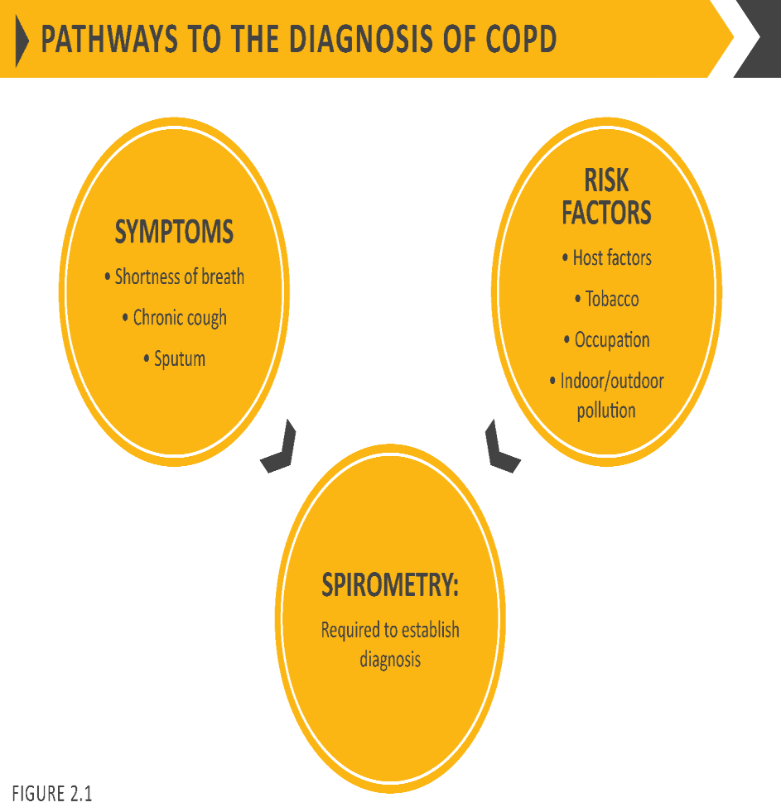

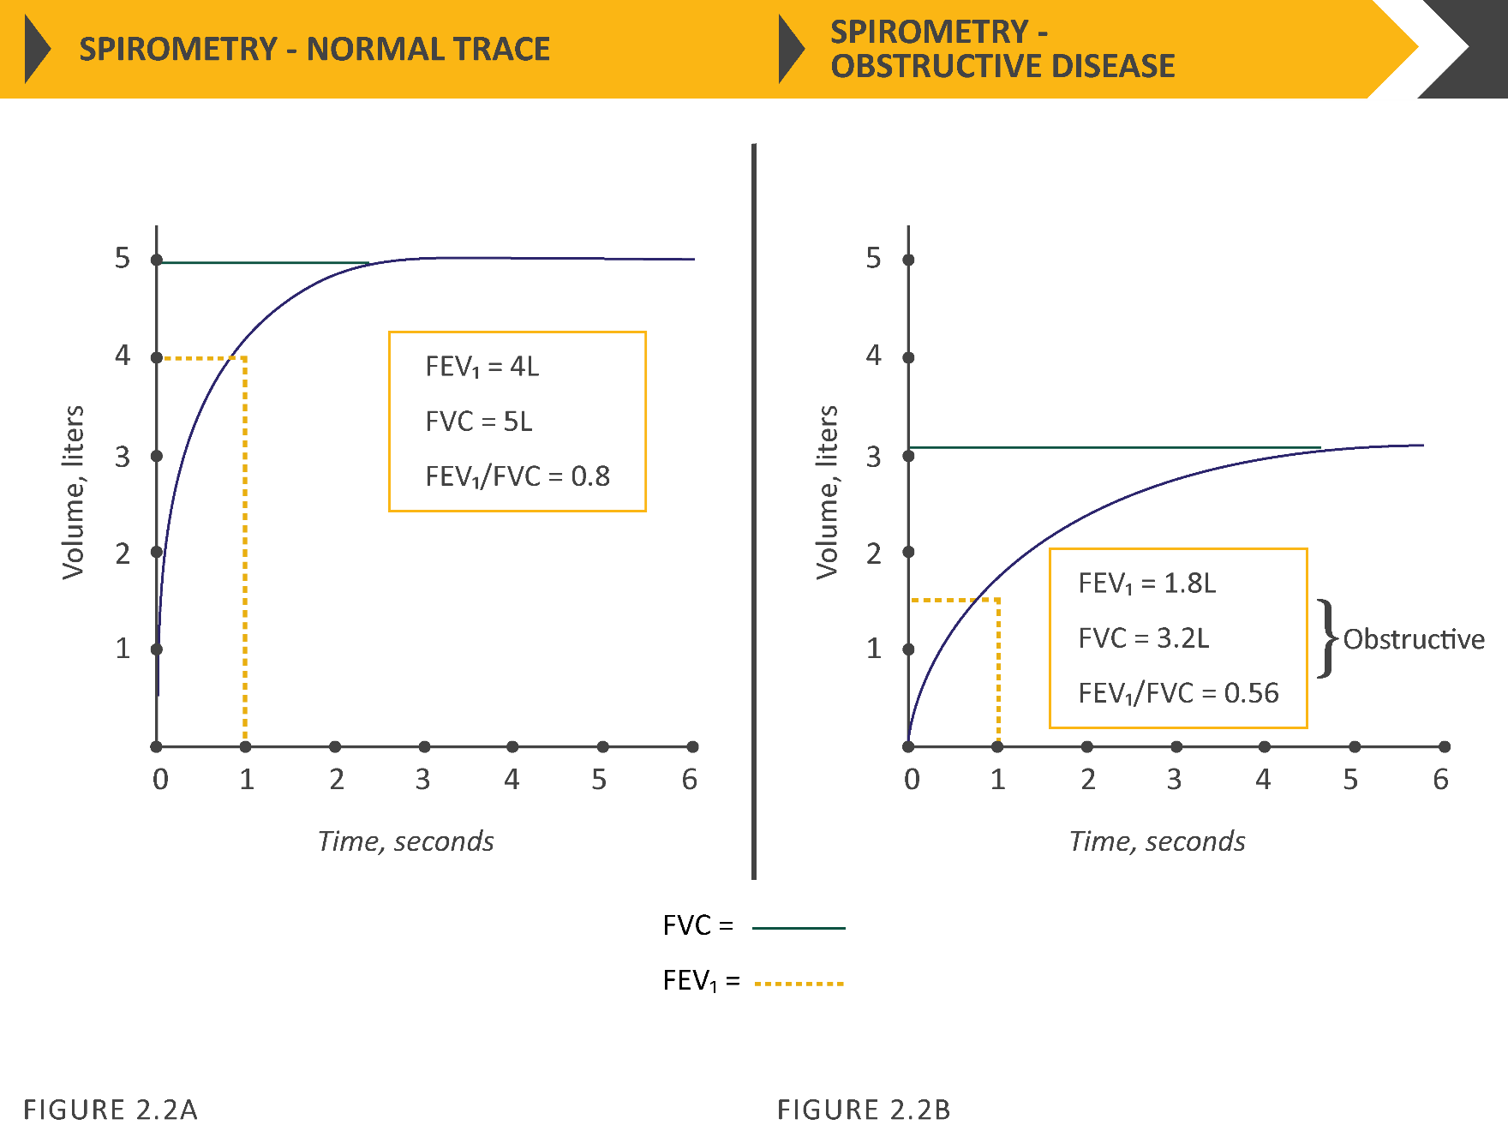

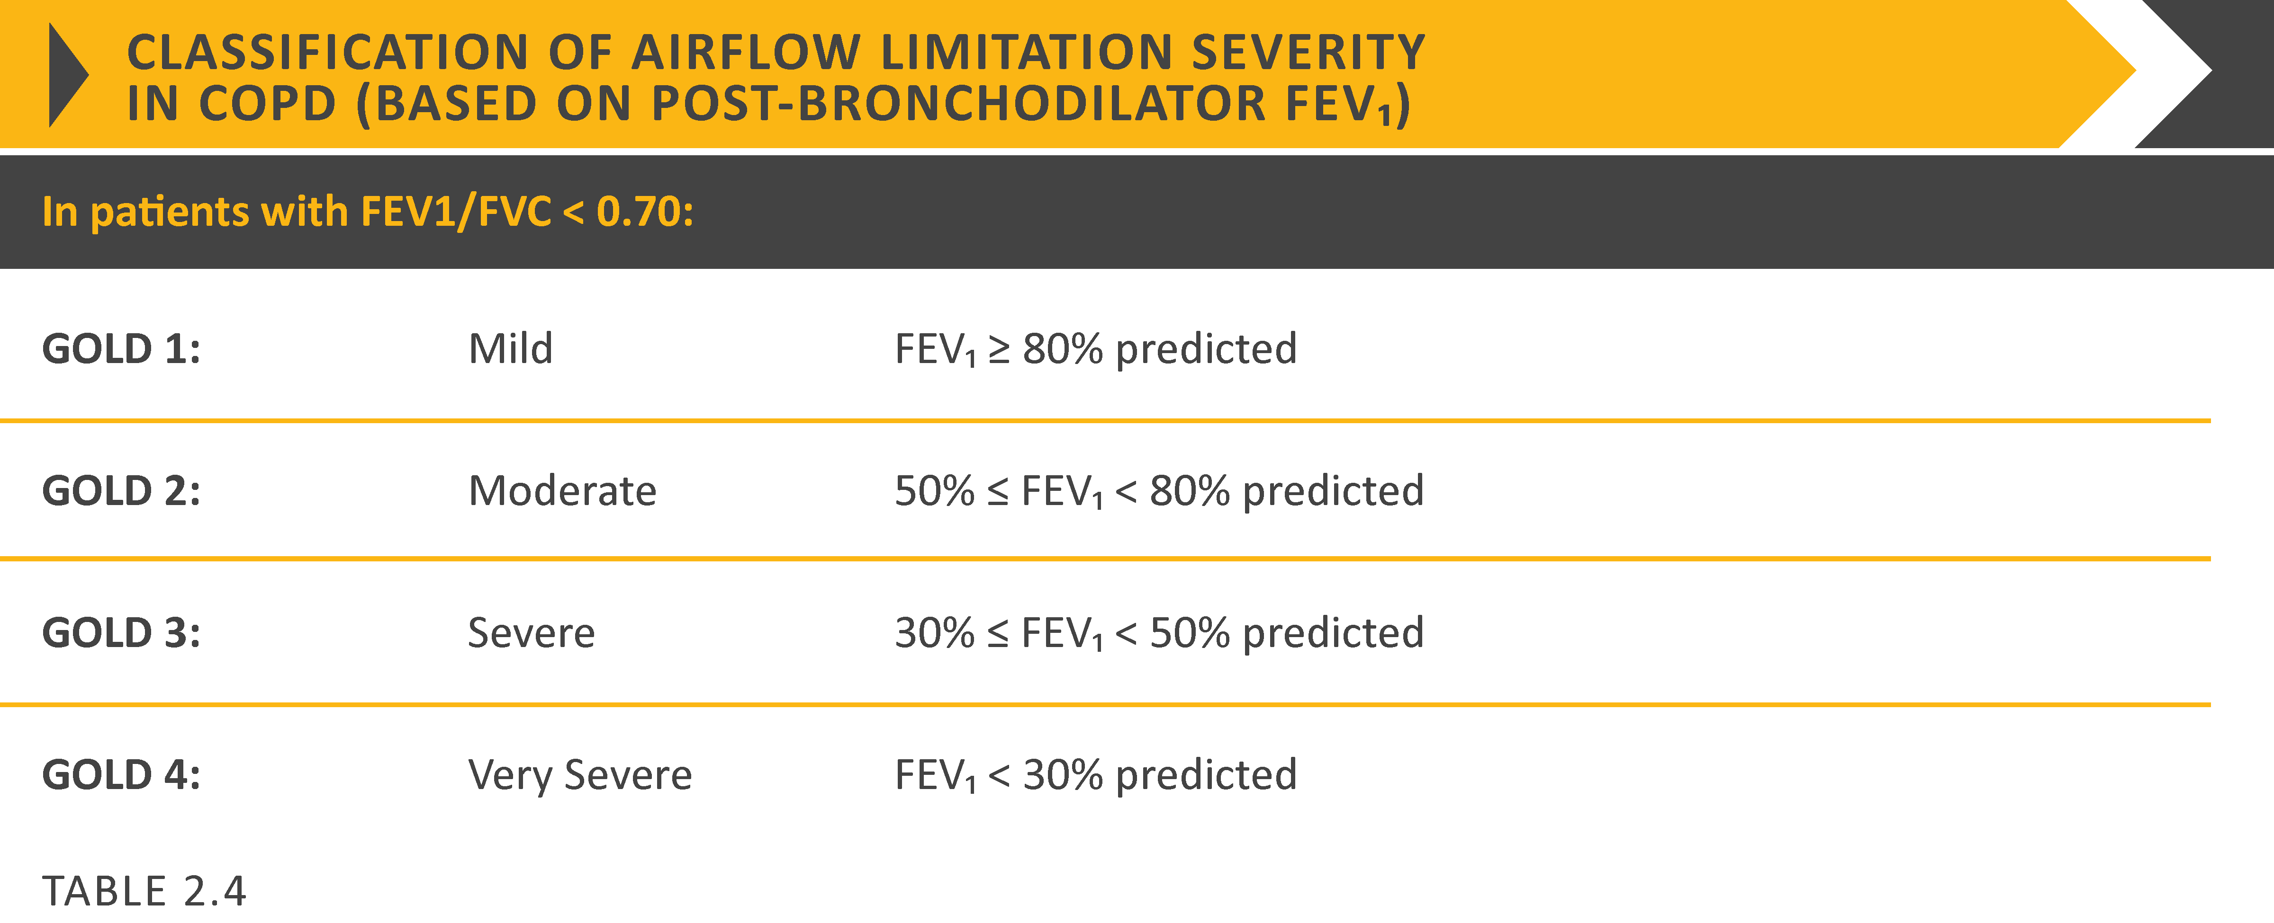

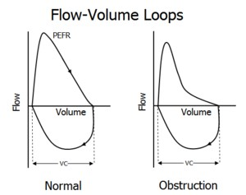
CAUSES/RISK FACTORS OF COPD
Tobacco smoking is the main cause of COPD and it is also the main determinant of a poor outcome in those who have the disease. Other factors may influence the risk of developing COPD De Marco et al., (2011). The host factors that seem to play a major role are age, genes, and early respiratory infections. Among environmental determinants, occupational exposures and exposure to biomass smoke are primary risk factors. The role of sex, socioeconomic status, and body mass index (BMI) on the risk of developing COPD is still open to debate. According to these authors, cigarette smoke is the most important risk factor for COPD also among young adults, and that smoking prevention could reduce the incidence of COPD in the young population by 29 to 39%. Their longitudinal study points out that subjects with BMI less than 18.5 kg/m2 had a threefold risk of developing the disease compared with subjects with a normal weight. While tobacco smoking is a major risk factor for COPD, only approximately 20% of smokers develop the disease. Previously, most of the studies on COPD mainly focused on smoking as a risk factor but recent studies showed that non-smokers also contribute a significant proportion of COPD. About 50% cases of COPD worldwide are related to smoking, and an estimated 10%-12% of individuals with COPD have never smoked (Lamprecht et al. 2011). More evidence is rising to suggest that other risk factors such as air pollution, respiratory infections, poor nutritional status, impaired lung growth, poor socio-economic status and genetic factors are also important for disease development (S. S. Salvi and Barnes 2009).
Occupational exposures to particulates, and possibly to ambient particulates, are associated with COPD. Increased COPD risk, and increased COPD mortality, has been observed among workers exposed to “vapours, gases, dusts, and fumes” (VGDF). Both large and small airway effects of VGDF exposures are suggested in the literature. Increased COPD risk has been associated with some speciﬁc occupational exposure agents, including: coal dust; welding and cutting gases and fumes; cement dust; diesel exhausts; organic solvents (J. Dement et al. 2015).

Exposure to Tobacco Smoke and Secondhand Smoke
Exposure to second-hand tobacco smoke can be a risk factor for COPD. Eva Hnizdo et al., (2002) conducted a study on US workers and found that >10 000 adults concluded that COPD attributable to work was 19% in the total population, and 31.1% among never smokers. They also added the sex-specific analyses and showed that for females, the adjusted odds ratios for COPD (number of cases/number of subjects exposed) were increased for rubber, plastics, and leather manufacturing overall (8/46; OR = 4.7, 95 percent confidence interval (CI): 2.7, 8.3) and for never smokers in that industry (2/31; OR = 3.8, 95 percent CI: 1.2, 12.3); for the textile mill products manufacturing industry overall (10/99; OR = 2.4, 95 percent CI: 1.2, 4.8) and for never smokers in that industry (3/53; OR = 6.0, 95 percent CI: 0.6, 62); for the agriculture industry overall (13/196; OR = 2.0, 95 percent CI: 0.9, 4.5) and for never smokers in that industry (6/134; OR = 2.3, 95 percent CI: 0.5, 10.4); for sales overall (40/512; OR = 1.6, 95 percent CI: 0.9, 2.9) and for never smokers in that industry (8/279; OR = 3.0, 95 percent CI: 0.7, 13); for food products manufacturing overall (9/123; OR = 1.5, 95 percent CI: 0.6, 4.0) and for never smokers in that industry (2/77; OR = 3.4, 95 percent CI: 0.3, 44); and for personal services overall (34/470; OR = 1.5, 95 percent CI: 0.7, 3.2).
Chronic tobacco smoking is the major risk factor for the development of COPD, but only a relatively small proportion of smokers develop airway obstruction. Although there is a dose-response relationship between FEV₁ and the extent of cigarette smoking, smoking history accounts for only approximately 15% of the variation in lung function. That is why the genetic predisposition of COPD may exist in smokers. Although cigarette smoking is the most important risk factor for the development of COPD, allergic airway inflammation, air pollutants, and diesel exhaust particles may also cause irreversible airflow limitation such as COPD. Environmental pollution, age, and airway hyperreactivity are also the risk factors (Hooper et al. 2012).
Menezes et al., (2005) reported that, there was a consistent pattern of higher prevalence in men, in older people, and in those with less education, lower body-mass index, and greater exposure to smoking. Among risk factors, tobacco smoking either active or passive, current or ex-smoking-all have a higher respiratory symptoms and lung function abnormalities, a greater annual rate of decline in FEV₁ and a greater COPD mortality rate than non-smokers.
Although prevalence varies across countries, in Bangladesh, it appreciably higher in smokers and ex-smokers compared with non-smokers, in those older than 40 years compared with those younger than 40 years and in men compared with women. Tobacco consumption, in the form of smoking or chewing, was found associated with an increased prevalence of COPD in four studies (Alam et al. 2015; R. S. R. Biswas et al. 2016; Islam et al. 2013; Mahfuz et al. 2014).
Alam et al., (2015) reported that both current smokers (OR: 5.5; 95% CI, 4.2-7.2; p < 0.001) and former smokers (OR: 4.5; 95% CI, 3.3-6.0; p < 0.001) were at a higher risk to experience COPD after adjusting potential confounders. He also made conclusion that, prevalence was three times higher in males compared to females (22% VS 6.4% by GOLD criteria and 16.2% VS 5.3% by LLN criteria) and about 60% higher in rural than urban populations (17% VS 9.9% by GOLD criteria and 12.5% VS 8% by LLN criteria). COPD was higher among individuals from households using biomass fuel compared to clean fuel (natural gas) users (17.3% VS 9.9% by GOLD criteria and 12.7% VS 7.9% by LLN criteria). The prevalence of stage I (mild), stage II (moderate), stage III (severe), and stage IV (very severe) COPD was 2.7, 8, 2.3, and 0.6%, and by the GOLD severity criteria and 1.2, 6.4, 2.2 and 0.5% by the LLN criteria. Increase in GOLD-defined COPD relative to the LLN largely occurred in those aged 60–69 years.
Biswas et al., (2016) conducted a study with rural women and found that, (>40 years old) having tobacco chewing habit were 13 times more likely to suffer from COPD (OR: 12.9; 95% CI, 3.4-49.4; p < 0.001). Among the 250 females, 150 (60%) were biomass fuel users and Natural gas/LPG users were 100 (40%). COPD was found in 41 (16.4%) biomass users and 10 (4%) in later. The frequency of COPD was 20.4% with a higher number in women who were using biomass then who were using natural gas/LPG (p<0.001). Regarding risk analysis, biomass fuel was found significantly associated with COPD (OR= 3.385, CI=1.606-7.135, p<0.05).
Exposures to second hand smoking at work and at home during adulthood were associated with increased COPD risk: odds ratio (OR) = 1.12 (95% confidence interval [CI]: 1.02–1.23; p = 0.01) and OR = 1.09 (95% CI: 1.00–1.18; p = 0.04) per 10 years of exposure adjusted for smoking and other covariates, respectively (Koeverden et al. 2015).
Increasing passive smoke exposure was independently associated with increased risk of COPD, with adjusted OR 1.05 (95% CI 0.93 to 1.18) for 1–19 h and OR 1.18 (95% CI 1.01 to 1.39) for 20 or more hours of exposure per week. Similar patterns (although attenuated and non-significant) were observed among never smokers. More marked dose–response relationships were observed between passive smoking exposure and respiratory symptoms, but the most marked effects were on the development of clinically significant COPD (airflow obstruction plus symptoms), where the risk among never smokers was doubled (OR 1.98 (95% CI 1.03 to 3.79)) if exposure exceeded 20 h/week (Jordan et al. 2011).
Exposure to Biomass Smoke and COPD
Biomass smoke is one of the major air pollutants and contributors of household air pollution worldwide. It is considered one of the leading environmental risk factors of several diseases, including COPD and acute lower respiratory disease, and is thought to cause 4 million deaths annually across the globe (Capistrano et al. 2017). Wood smoke and other biomass exposure have been shown to be independent risk factors for obstructive airways disease, and earlier and longer time of exposure has been shown to increase the risk for development of COPD (S. Salvi and Barnes 2010). According to Ocakli et al., (2018), the combustion of biomass fuels has now been recognized as a relevant risk factor for respiratory disorders, such as chronic bronchitis and COPD, asthma, lung cancer, lung fibrosis, and tuberculosis.
Biomass smoke exposure is a prominent risk factor for developing several airway diseases. For example, relative to non-exposed people, those exposure to biomass smoke have an odds ratio of 2.44 (95% CI, 1.9–3.33) for developing COPD (Hu et al. 2010). While among women over 30 who were predominantly undertaking domestic duties in rural areas the relative risk for COPD was estimated as either 3.2 (95% CI 2.3–4.8) (Ezzati et al. 2004) or 2.14 (95% CI 1.78–2.58) (Balmes 2010).
A systematic review and meta-analysis identified 23 studies, 10 reporting COPD based on both physician diagnosis and spirometry definitions, 11 reporting chronic bronchitis based on respiratory questionnaire data, and two reporting both COPD and chronic bronchitis. The pooled effect estimates for lung function diagnosed COPD (OR 2.96, 95% CI 2.01–4.37) was greater than those diagnosed by a doctor in hospital (OR 2.29, 95% CI 0.70–7.52), with a combined pooled effect estimate of 2.80 (95% CI 1.85–4.23) for COPD. Similarly, the pooled effect estimates for chronic bronchitis was 2.32 (95% CI 1.92–2.80) of chronic obstructive pulmonary disease (COPD) in populations exposed to solid fuel smoke (Kurmi et al. 2010).
The odds of having biomass fuel smoke exposure among males were 4.25 while in the female it was 4.37. Overall OR is 3.16. The odds of having other types of indoor pollution such as wood exposure, coal and stove exposure in COPD patients are 2.70, 2.45, and 2.05, respectively, in comparison to the control group. Among the above exposures, biomass fuel smoke, wood smoke exposure, and coal smoking were statistically significant with value of P = 0.0001, 0.003, and 0.02, respectively (Madhurmay et al. 2019).
Hu et al., (2010) conducted a meta-analysis with 15 epidemiologic studies covering a wide range of countries and found that people exposed to biomass smoke had combined odds ratio (OR) of 2.44 for developing COPD as assessed by lung function measurements or symptom-diagnosed chronic bronchitis, and that this was true for both women and men. Moreover, cigarette smoking appeared to have a synergistic effect with biomass smoke, increasing the OR for COPD development to 4.39.
In Bangladesh, many studies found significant association was reported with the development of COPD and the use of biomass fuel for cooking purpose in three studies (Alam et al. 2015; Alim et al. 2014; R. S. R. Biswas et al. 2016). Two moderate-quality studies found that biomass fuel use was positively associated with a higher prevalence of COPD among rural women (Alim et al. 2014; R. S. R. Biswas et al. 2016). The women in rural areas suffer more from COPD than those in urban areas. According to that study, exposure to biomass smoke (from open stoves/wood fires) appears to be a significant risk factor for the disease in village women.
Alam et al., (2015) studied with nearly 4,000 urban and rural participants also found that biomass fuel users were six times more likely to have COPD compared to clean fuel users (OR: 5.9; 95% CI, 1.0-34.5; p = 0.047).
Association of COPD and Socio-Demographic profile
Many studies from developed countries suggested that socioeconomic status (SES), measured by income and educational level, is associated with lung function and COPD in terms of exacerbation, prevalence and mortality. This association may be partly explained by the greater proportion of smokers among people in lower socioeconomic groups, but smoking may not explain all the association.
Yin et al., (2011) conducted a study to clarify the association between COPD and socioeconomic status. They include 51,520 subjects sampled from 31 provinces, autonomous regions and municipalities, 49,363 subjects with complete data were included in the analysis in that report. The overall crude prevalence of COPD was 2.9% (95%CI 2.8-3.1) based on self-report. Standardized to world standard population 2000, the prevalence rate of COPD was 2.2% (95%CI 2.1-2.4%). Among 1423 subjects with COPD, 53.1% were never smokers. The prevalence among men was significantly higher than among women (3.4% vs. 2.4%, p < 0.001), rural area higher than urban area (3.1% vs. 2.5%, p < 0.001), and western areas (3.7%) higher than central (2.7%) and eastern (2.2%) areas (table 2). The prevalence increased with age, from 0.8% in the youngest age group (15-29 years) to 7.5% in the eldest age group (60-69 years). Former smokers had a higher prevalence of COPD (9.0%) compared to current smokers (3.3%) and never smokers (2.3%). Those with educational level < 9 years had a higher COPD prevalence than subjects with educational level ≥ 12 years (4.2% vs. 1.6%, p < 0.001). Similarly, subjects with low household income had a higher prevalence of COPD compared with those with high household income (4.1% vs. 2.2%, p < 0.001). Educational level and household income were associated with significantly higher prevalence of COPD in both urban and rural areas. After adjusting for age, sex, smoking status, passive smoking and geographic regions, the odds for those with < 9 years educational level were 1.67 (1.32-2.13) in urban and 1.76 (1.34-2.30) in rural areas compared with subjects with education ≥ 12 years. The trend was significant in crude and adjusted model. Compared to subjects with high household income, those with low household income had a higher risk of COPD prevalence (OR 1.64, 95%CI 1.28-2.09) in urban areas. Low household income was associated with high COPD prevalence in rural areas in crude analysis, but not after adjustment for potential confounders (p for trend = 0.466). When stratified by smoking status, there was still a significant association between educational level and prevalence of COPD in both smokers (OR 1.64, 95%CI 1.26-2.12) and never smokers (OR 1.77, 95%CI 1.40-2.25), suggesting that educational level is a risk factor for COPD independent of smoking. The association between household income and COPD was observed in never smokers, but not in smokers. Due to the potential change in educational attainment and income between 15-30 years, we repeated the analysis in a subgroup of subjects aged 30-69 years and found similar trend and pattern observed among all study subjects.
Grigsby et al., (2016) defined SES as an individual’s social and economic standing and serves as proxy for social or economic position or rank in a social group. More than a measure of income, SES encompasses several other measures including education, occupation, housing, assets, and participation in social organization. While lower SES was found to be associated with greater COPD morbidity and mortality in high-income countries (HIC), few studies have examined the role of low SES in the prevalence of COPD among low- and middle-income countries (LMICs). An understanding of the role of SES and COPD in LMICs will potentially inform public interventions beyond harm reduction, i.e., tobacco cessation and decreased biomass fuel smoke exposure, toward those aimed at disparities in SES. Analysis using multivariable alternating logistic regression showed that the odds of having COPD was positively associated with use of biomass as a primary fuel source for cooking, daily smoking, not having completed secondary education, lower monthly household income, and older age. We found a positive association between the odds of COPD and a lower SES composite score, with an interquartile OR of 1.23 (95% CI 1.05–1.43). In sensitivity analyses, the positive association between low SES and COPD remained significant (interquartile OR 1.29, 95% CI 1.12–1.50) when we used the Global Lung Function Initiative (GLI) Caucasian reference population. In further sensitivity analyses, we analyzed differences using pack-years and categories of smoking history (current, former, or never smoker) instead of daily smoking or not, while adjusting for age, sex, biomass fuel smoke exposure, and site. The interquartile OR for SES was 1.20 (95% CI 1.01–1.41) when using pack-years and 1.18 (95% CI 1.03–1.34) when using categories of smoking history. These results were very similar to using daily smoking vs not (interquartile OR for SES of 1.23, 95% CI 1.05–1.43).
Kanervisto et al., (2011) conducted a study with low education, low income and other risk factors associated with the development of COPD (n = 588) included those with both diseases (n = 96) by univariate and multivariate logistic regression. Low education. low income and other risk factors associated with the development of COPD (n = 242) excluded those with both diseases (n = 96) by univariate and multivariate logistic regression. Obesity increased the risk for asthma, whereas underweight increased the risk for COPD (Table 2, Table 3). In COPD smoking was a risk factor for both genders (women OR 2.5, 95% CI 1.7–3.7 and men 2.3, 95% CI 1.4–3.8). In men underweight was a risk factor for COPD (OR 2.4, 95% CI 1.1–5.0). Basic educational level increased the risk for COPD in both genders (women OR 1.8, 95% CI 1.0–3.3 and men 1.8, 95% CI 1.0–3.0). There was a clear association in the univariate analyses with low education and low household income in both groups. Basic educational level increased the risk of COPD increased if education was lower. Similarly, low household income increased the risk for asthma and COPD. In the multivariate logistic regression analysis when adjusted for gender, age, smoking history, and BMI, the basic educational level remained an independent determinant for COPD and the low household income for asthma. Underweight and smoking were determinants of COPD. Female gender was a determinant for asthma and male gender for COPD. The risk for COPD increased significantly with age, but the connection between age and asthma was not as clear-cut.
Whilst those with an interest in historic workplace exposures may largely regard this relationship as causal, implying that certain work exposures can cause COPD, others may see the clear financial and social disadvantages suffered by COPD patients unable to work.
Old age was reported as a risk factor for COPD by two studies (Alam et al. 2015; Islam et al. 2013). Alam et al., (2015) observed that 50-59 years-aged people and 60-69 years-aged people were two times and five times more likely to develop COPD, respectively, compared to 40-49 years-aged people (50 to 59 years, OR: 2.2, 95% CI, 1.6-3.0; p < 0.001; 60 to 69 years, OR: 4.7, 95% CI, 3.5-6.4; p < 0.001).
During a mean follow-up of 13.5 ± 5.3 years, a total of 2,877 individuals (47.5% men) were discharged from hospital with first-ever COPD as the primary diagnosis. The study showed that low annual income in quartile (Q) 1 and Q2 ((HR: 2.10; 95% CI: 1.83–2.40, P < 0.001 and HR: 2.23; 1.97–2.53, P < 0.001, respectively) were associated with higher risks for COPD. Individuals with rented housing (HR: 1.41; CI: 1.30–1.52, P < 0.001) had higher COPD risk compared to living in self-owned property. (Borné et al. 2019).
Occupational exposure to silica dusts and COPD
Occupational exposures such as to vapors, gases, dusts and fumes present an important risk factor for the development of the disease, by itself and through interaction with other risk factors (Eva Hnizdo et al. 2002). The epidemiological evidence supporting the role of occupational exposures (organic and inorganic dusts, metal fumes, chemical vapors) as risk factors has been published in population-based studies, and also studies regarding working environments with specific exposures (P. D. Blanc, Iribarren, et al. 2009).
Occupational exposure to crystalline silica (silica) dust occurs in many industrial operations worldwide (Yassin, Yebesi, and Tingle 2005). The reduction of silica dust exposure levels in most developed countries during the last century resulted in dramatic decreases in morbidity and mortality from silicosis and silica dust associated tuberculosis (TB). Despite this, chronic obstructive pulmonary disease (COPD) remains a health issue in workers exposed to silica dust (E. Hnizdo and Vallyathan 2003).
It is therefore likely that certain properties of silica dust can cause COPD that may precede, or be independent of, silicosis development. Recent clinicopathological and experimental studies help to explain the potential for silica dust to cause pathological changes that may lead to the development of COPD (E. Hnizdo and Vallyathan 2003).
It is more difficult to estimate the specific contribution of occupational exposures because of the strong causal association with tobacco smoking and the late onset, often after retirement age. Nevertheless, about 15% of all COPD cases in Western societies have been attributed to exposure to vapours, gas, dust or fumes, mainly based on past occupational studies in the highly exposed mining, textile and farming sectors (Paul D. Blanc 2012). Recent large population-based epidemiological studies that have been able to control for smoking and other potential confounding factors, such as asthma, have found occupations at increased COPD risk even at lower community exposure levels (De Matteis et al. 2016). In addition, the American Thoracic Society’s consensus statement suggests that between 10% and 20% of COPD is attributable to workplace exposures (American thoracic society statement: Occupational contribution to the burden of airway disease 2003).
The current thinking is that chronic inflammation and remodelling of small airways (bronchitis) and destruction of lung parenchyma (emphysema), in response to inhalant oxidants generated by smoking and other environmental exposures, leads to COPD (Angelis et al. 2014). The predominant inflammatory cells involved in the airways remodelling and parenchymal destruction characteristic of COPD are neutrophils, macrophages, and T lymphocytes (CD8+ and CD4+) (Y. Wang et al. 2018).There are several potential mechanisms by which silica particles can initiate cell injury leading to COPD. These include cytotoxicity, leading to generation of reactive oxygen/nitrogen species, and secretion of proinflammatory factors, cytokines, chemokines, elastase, and fibrogenic factors (Boukhenouna et al. 2018). Potentially these mechanisms can initiate changes in lung tissue leading to airflow obstruction as follows: (a) silica particles can initiate toxic and inflammatory processes in conducting and peripheral airways, and alveolar tissue characterised by release of mediators leading to increased production of oxidants, cytokines, chemokines, and elastase, inducing airways inflammation and emphysema (Ni, Chuang, and Zuo 2015); or (b) silica particles can cause epithelial cell injury that facilitates penetration of the silica particles through the walls of small airways and causes localised fibrosis (Yacobi et al. 2011).
Mechanism by which Silica dust can induce Emphysema and chronic bronchitis
Silica pathogenesis:
In epidemiologic and pathologic studies occupational exposure to crystalline silica is the important risk factors identified to be associated with the development of emphysema
The mechanism by which silica can produce emphysema is not well understood. Current evidence suggests that the mechanism is similar to that of cigarette smoke that is, the destruction of α1 protease inhibitor (α1-AT) by oxidants generated by inﬂammatory cells as well as silica dust (Robinson, Tuder, and Hunt 2013). Emphysema induced by cigarette smoke is initiated by the oxidants in cigarette smoke causing a protease antiprotease imbalance and decreased anti-elastase activity (Kubo et al. 2019). It is postulated that silica may induce emphysema by the release of proteolytic enzymes from dust evoked inﬂammatory cells and by oxidative inactivation of α1-AT by the excessive oxygen free radicals generated by silica particles and inﬂammatory cells (Domej, Oettl, and Renner 2014).
Epidemiological studies show that the prevalence of chronic bronchitis (chronic productive cough) increases with intensity and duration of silica exposure (Lahousse et al. 2017). A clinicopathological study of COPD among South African gold miners found that in the absence of emphysema, a marked degree of mucus glands hyperplasia is associated with little airﬂow obstruction. Furthermore, marked mucus glands hyperplasia was associated mainly with rhonchi, sputum production, and cough during life, but less with symptoms of breathlessness which were associated strongly with emphysema (Smith and Woodcock 2006).
Occupational exposure is an important risk factor for chronic obstructive pulmonary disease (COPD), and silica dust is one of the most important occupational respiratory toxins. In summary, deaths from COPD likely constitute a large proportion of deaths from non-malignant respiratory disease (NMRD) in silica dust exposed workers. Silica dust exposure increases mortality from COPD and the effect is modified by tobacco smoking. Evidence to help assess cause(s) of COPD in an established case is generally lacking (for example the relative contributions of smoking, coal dust exposure and family history of COPD in a retired coal miner). Whilst results from studies discussed later in this article are broadly useful in advising patients about the general harm caused by dusty occupations, the results do not normally translate sufficiently well to help inform individual cases. This is probably because most previous studies have been designed to assess the respiratory harm caused by individual workplaces with known exposures, or to measure excesses of COPD in certain population groups. Numerous mortality studies of cohorts of silica dust exposed workers report increased mortality from non-malignant respiratory disease (Steenland and Brown 1995).
Epidemiological and clinicopathological studies investigated whether silicosis or other silica dust associated pathological changes cause airflow obstruction in silica dust exposed workers. Two case-control studies compared lung function in South African gold miners with and without radiological signs of silicosis, who were matched for cumulative dust exposure, tobacco consumption, and age. No significant differences were found between silicosis and non-silicosis miners in spirometry (Irwig and Rocks 1978).
Epidemiological studies show that silica dust exposure can lead to airflow obstruction in the absence of radiological signs of silicosis (Meijer, Kromhout, and Heederik 2001) and that the association between cumulative silica dust exposure and airflow obstruction can be independent of silicosis (Irwig and Rocks 1978). About 15–20% of COPD cases are due to occupational exposures to pollutants at the workplace (Gibson et al. 2013).
Combined effect of silica dust and smoking with COPD
Work may have an interactive effect with tobacco smoke, resulting in greater severity of disease with greater disability or by accelerating the rate of loss of lung function among those with the disease (Harber et al. 2007). It is well known that tobacco smoke and occupational exposures exert a synergistic effect and increase each other′s influence (Ameille et al. 2006).
Several studies have shown that smoking can potentiate the effect of silica dust. Studies of Canadian and US hard rock miners found that the effect of silica dust on lung function pattern is different in smokers compared to non-smokers (Lai et al. 2018).
Mazitova et al., (2012) explained odds ratios for different types of occupational noxious particles and gases among COPD patients were highest for silica dust (OR=6.2; 95 % CI=3.6 to 10.7; p<0.0001). Occupational risk assessment calculated separately for non-smoking and smoking workers showed that the odds ratios for occupational COPD were significantly higher for non-smokers. For the smoking workers, smoking was a major risk factor for COPD development (Table 3). Thus, the odds ratio for occupational COPD for non-smokers was almost seven times higher than that of smokers and their attributable risk for occupational COPD was more than 95 % compared to 65 % for smokers.
Thus, after matching on cumulative silica dust exposure and smoking, radiological signs of silicosis were not associated with significant airflow obstruction. These results support the hypothesis that the effect of cumulative silica dust exposure on airflow obstruction seen in the cohort of South African gold miners is independent of silicosis (Wiles and Faure 1975).
E. Hnizdo et al., (1990) conducted a study on South African gold miners estimated the fraction of cases with severe airflow obstruction attributable to dust only, smoking only, and the combined effect of the two exposures (that is, the attributable fractions), and the fraction of cases that could be prevented by removal from each exposure. The attributable fractions for severe airflow obstruction (found in 20% of miners) were estimated as 8% for dust alone, 42% for smoking, 40% for the combined effect of silica dust and smoking, and 10% for unknown factors. Estimated preventable fractions show that elimination of silica dust exposure would prevent 48%, and elimination of smoking 82% of severe airflow obstruction. Despite smoking being the most important risk factor for this disease, accounting for >75% of cases of disease, occupational exposures, alone or in combination with smoking, are responsible for a substantial proportion of disease (Eisner et al. 2010).
The studies found increasing exposure-response trend for COPD mortality and cumulative dust exposure that was modified by tobacco smoking. The attributable fractions for COPD mortality were estimated as 5% for dust alone, 34% for smoking, 59% for the combined effect of silica dust and smoking, and 2% for unknown factors. In the absence of silica dust exposure, 64% of COPD deaths could be prevented, whereas in the absence of smoking, 93% of COPD deaths could be prevented (E. Hnizdo, Baskind, and Sluis-Cremer 1990).
Furthermore, it has been reported that occupational exposures, such as to vapors, gas, dust or fumes, might trigger COPD exacerbations in a similar way to that in which they elicit asthma attacks (Paulin et al. 2015). Paulin et al., 2015 conducted a multicenter cohort study including current and former smokers with and without COPD, Participants with COPD were 40 to 80 years old. In that study, association between occupational exposure with COPD, it was not statistically significant (odds ratio [OR], 1.20; 95% confidence interval [CI], 0.92–1.56) in bivariate analysis; however, after adjustment for potential confounders, including smoking, occupational exposure was associated with a higher point-estimated odds of COPD, which was statistically significant (OR, 1.44; 95% CI, 1.04–1.97). Occupational exposures were associated with greater odds of COPD among former smokers as compared with current smokers (OR, 1.75; 95% CI, 1.15–2.66 vs. OR, 1.09; 95% CI, 0.66–1.82; smoking- exposure interaction, P =0.06) and among those with fewer versus more pack-years of smoking (OR, 1.97; 95% CI, 1.27–3.05 vs. OR, 1.02; 95% CI, 0.64–1.61; pack-years–exposure interaction, P =0.05). There was no substantive difference between male and female smokers and the odds of COPD (men: OR, 1.44;95% CI, 0.95–2.17 vs. women: OR, 1.41; 95% CI, 0.85–2.31; sex–exposure interaction, P =0.74). When defining COPD using LLN criteria (n = 595), there was an association between occupational exposures and COPD in bivariate (OR,1.44; 95% CI, 1.12–1.85) and multivariate (OR = 1.57; 95% CI, 1.18–2.10) analyses.
In Bangladesh, Alam et al., (2015)reported that individuals with a history of asthma had seven times higher probability of developing COPD, even after adjusting for smoking history and other potential confounders (OR: 6.9; 95% CI, 4.9-9.5; p < 0.001).
In summary, the evidence shows that smoking potentiates the effect of silica dust exposure on airflow obstruction. Thus, eliminating or decreasing both dust and smoking, occupational exposure, asthma are some important which associated with COPD.

METHODOLOGY
Study Type:
This study was a cross-sectional observational study.
Place & Period of Study:
The study was carried out in the stone quarries of Companiganj and Gowainghat Upazila, Sylhet and the control subjects were collected from Sylhet MAG Osmani medical college.
The study was carried out during the time of one year after acceptance of the protocol. This study period was divided into 2 phases. First phase included problem identification, literature review, protocol writing, questionnaire preparation and pre-testing. Second phase included data collection, analysis and report writing. Schedule of study period is attached in the appendices (Appendix - XXX).
Target Population & Study Population:
All stone quarry workers of Companiganj and Gowainghat Upazila, Sylhet were the target population. Moreover, all patients admitted in medicine ward were considered as control population….
Target population fulfilling the following eligibility criteria within the given period were enrolled in the study as study population.
Eligibility criteria:
- Workers in the age range of 25 years to 60 years.
- Workers who have been working for at least five years in the quarry.
Exclusion criteria:
- Workers with history of lung disease even before they started working at the quarry.
- Workers who are not interested to participate in the study.
Quality assurance strategy:
All the data will be kept confidential. Only the researcher and ethical committee members will get full access to the data. Every record will be cross-checked by the supervisor.

Addressing Ethical Issues:
- The study protocol will be submitted for the approval of the ethical review committee of Sylhet MAG Osmani Medical College, Sylhet.
- Informed written consent will be taken from each of the respondents before taking any interview. A co-worker will be the witness of taking informed consent.
- The purpose and method of the study, confidentiality of the interviews, risks and benefits of participating in the study, respondent’s right to participate voluntarily and right to withdraw at any point will be explained in the local language from a printed handout.
- All information will be collected with complete respect to the worker’s wish and without any force or pressure.
Determinations of Sample:
Sample size was calculated using Cochran’s formula considering 5% level of significance, 5% precision level (permissible error) and prevalence of chronic obstructive pulmonary diseases among stone quarry workers 13.7% (john dement et al., 2015).
The formula is: n = 
Where, n = estimated sample size
Z = 1.96 (in 95% Confidence Interval)
p = prevalence, 13.7% (0.137),
q = 1- 0.12 = 0.87,
d = permissible error, 5% (0.05)
So, sample size (n) = 
= 180
Calculated sample size was 180 but we collected data from 200 respondents. Among the 200 hundred subjects, 106 respondents were smoker. So, for our convenient, all control subjects were from smoker and then the size of the data for control subject were 100. Moreover, the control subjects were selected from the Sylhet M A G Osmani hospital.
Sampling Method:
Consecutive sampling method was used to recruit the required number of respondents in the study.
Variables Studied:
- Main outcome variable: COPD
- Exposure variable: Silica
- Confounding variables:
1. Smoking including duration of smoking
2. Length of service
3. Use of biomass fuel in cooking
4. low socioeconomic condition.
Operational Definitions:
- FEV1: The volume of air that the patient can exhale in the first second of forced expiration after a maximal inspiration
- FVC: The total volume of air that the patient can forcibly exhale in one breath after a maximal inspiration
- FEV1/FVC: The ratio of FEV1 to FVC expressed as a percentage.
- COPD: Subjects with compatible history and forced expiratory volume in 1 second and forced vital capacity ratio (FEV1/FVC) value of less than 0.7 will be regarded as COPD patients.
Procedure of Data Collection:
- This study was conducted on the stone quarries of Sylhet, specifically on the quarries that have stone crusher machines and in Sylhet MAG Osmani medical college.
- Total 15 visits were made during the study. On each visit, data were collected from 20 respondents.
- Prior to each day of data collection for case individuals, an advocacy meeting was arranged with the local elites and the respective industry owner. They were informed in detail about the study and permission were taken.
- An announcement was also made on the day before data collection in the quarry area mentioning `health checkup was done for the employees working for 5 years or more'.
- After relevant history taking, workers fulfilling the inclusion criteria was informed about the study goals. Among them who was agreeing to participate voluntarily, was taken as samples.
- Informed written consent was taken from the respondents.
- Study population was divided into two group: smoker and non-smoker.
- Workers were interviewed face to face using the semi-structured questionnaire.
- Baseline spirometry was performed for all the participants of the study. Spirometry was carried out using a calibrated portable spirometer.
- Spirometry was done with participants sitting at ambient temperature and after at least 10 minutes of rest.
- The subjects were asked to exhale into the spirometer as forcefully as possible after maximum inspiration.
- The parameters measured was forced vital capacity (FVC) and forced expiratory volume in one second (FEV1). FEV1/FVC ratio will be calculated from the measured data.
- Study participants with value of FEV1/FVC of less than 0.7 was examined with post-bronchodilator test according to the ATS / ERS guideline, 15 minutes after the administration of 400 micrograms of salbutamol.
- Subjects with forced expiratory volume in 1st second and forced vital capacity ratio (FEV1/FVC) value of less than 0.7 was regarded as COPD patients.
- The stages of COPD were also determined according to GOLD criteria.
- All relevant data was recorded in data collection sheet designed for this study.
Laboratory Procedure:
Data Collection:
Data were collected in a pre-designed data collection sheet containing the variables of interest (Appendix – XXX).

Statistical analysis:
- Data were processed manually in Excel and analyzed with the help of SPSS (Statistical package for social sciences) Version 25.0
- Quantitative data were expressed as mean and standard deviation.
- Qualitative data will be expressed as frequency and percentage and/or bar diagram or Pie chart.
- For making association between exposure (smoker and silica exposure versus smoker) and outcome (COPD versus Not COPD), we applied logistic regression. Moreover, to calculate association between two categorical variables, the Chi-square test was also used.
- All analyses were assessed with 5% level of significance. That means, an effect of a variable is significant if the P-value is less than 0.05 (5%).

Flow chart for the steps of study:
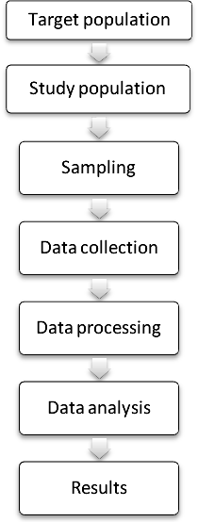
RESULTS
In this study, information on 200 stone quarry workers from Companiganj and Gowainghat Upazila, Sylhet were collected using systematic questionnaire. Moreover, information on 100 control respondents from Sylhet MAG Osmani medical college hospital was collected. We analysed data in three steps. In the first step, all workers (n=200) were included in the analyses; in the second step, analyses were conducted using information only from those who have been identified for COPD (n=78) in silica exposure group; and finally, analyses were conducted using 206 respondents, in which 106 were cases and 100 were control.

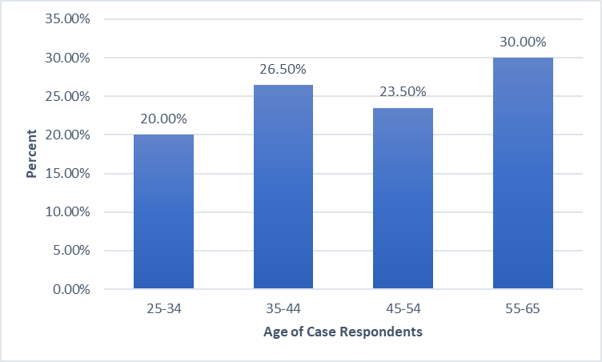
Fig. 1: Distribution of the respondents based on age group (n=200)
Fig 1 shows the distribution of age groups of 200 workers. Among the different age groups, the highest number of workers 30.0% laid on 55-65 years of age group and smallest percentage of workers 20% laid on 25-34 years of age group.

Table I: Distribution of sex of respondents (n=200)
Sex of Respondent | Frequency | Percent
Male | 131 | 65.5
Female | 69 | 34.5
Total | 200 | 100.0

Table I represents the percentage of gender of the 200 workers. Among male and female, the highest number of workers 65.5% (n=131) were male and smallest percentage of workers 34.5% (n=69) were female.

Table II: Distribution of Smoking of respondents (n=200)
Smoking Status | Frequency | Percent
Yes | 106 | 53.0
No | 94 | 47.0
Total | 200 | 100.0

Table II represents the percentage of the workers’ smoking status. Among the smokers and non-smokers, the highest number of workers 53% (n=106) were smoker and smallest percentage of workers (47%) were non-smoker.

Table III: Distribution of Smoking and Pattern (n=200)
Smoking | COPD |  | Total | p-value
Smoking | No  (n=122) | Yes  (n=78) | Total | p-value
Yes | 56 (45.9) | 50 (64.1) | 106 (53.0) | 0.012*
No | 66 (54.1) | 28 (35.9) | 94 (47.0) | 0.012*
*P-value calculated from the Chi-square test.

Table III represents the percentage of COPD pattern with the workers smoking status. Among the 200 workers, 122 were no COPD. Among them, 45.9% (n=56) were smoker and 54.1% (n = 66) were non-smoker. Among the total workers, 78 had COPD. Among them, 64.1% (n=50) were smoker and 35.9% (n=28) were non-smoker.

Table IV: Distribution of length of service of respondents (n=200)
Working Length | Frequency | Percent
5-10 Years | 118 | 59.0
10-15 Years | 43 | 21.5
15+ Years | 39 | 19.5
Total | 200 | 100.0

Table IV represents the percentage of the workers in different service length. Among the different groups, the highest number of workers 59% (n=118) has a service length between 5-10years and smallest percentage of workers 19.5% (n=39) has a service length about 15+ years.

Table V: Distribution of Protective equipment using among the respondents (n=200)
Protective equipment | Frequency | Percent
Users | 26 | 13.0
No-user | 174 | 87.0
Total | 200 | 100

Table V represents the percentage of the workers’ using protective equipment during work. Among users and non-users, the highest number of workers 87% (n=174) were non-users and smallest percentage of workers 13% (n=26) were users of protective equipment.

Table VI: Distribution of body mass index (BMI) category of the respondents (n=200)
BMI Category | Frequency | Percent
Underweight | 42 | 21.0
Normal | 141 | 70.5
Overweight | 17 | 8.5
Total | 200 | 100

Table VI represents the percentage of BMI category of workers. Among underweight, normal weight and overweight workers, the highest number of workers 70.5% (n=141) were belong to normal and smallest percentage of workers 21.0% (n=42) were in underweight, rest were overweight.

Table VII: Distribution of cough in the respondents (n=200)
Cough | Frequency | Percent
Yes | 100 | 50
No | 100 | 50
Total | 200 | 100

Table VII represents the percentage of having cough in workers. Among all workers, having cough or not having cough have equal percentage (50%) in both groups.

Table VIII: Distribution of sputum production in the respondents (n=200)
Sputum Production | Frequency | Percent
Yes | 57 | 28.5
No | 143 | 71.5
Total | 200 | 100
Table VIII represents the percentage of sputum production among the worker. Among all workers, the highest number of workers 71.5% (n=143) have no sputum and smallest percentage of workers 28.5% (n=52) have sputum.

Table IX: Distribution of breathlessness in the respondents (n=200)
Breathlessness | Frequency | Percent
Present | 95 | 47.5
Absent | 105 | 52.5
Total | 200 | 100

Table IX represents the percentage of breathlessness of the worker. Among breathlessness category, the highest number of workers 52.2% (n=105) were informed of no breathlessness and smallest percentage of workers 47.5% (n=95) were said “yes”.

Table X: Distribution of COPD pattern among the respondents (n=200)
Pattern | Frequency | Percent
Obstruction (NR) | 78 | 39.0
Obstruction(R) | 11 | 5.5
Restriction | 36 | 18.0
Normal | 75 | 37.5
Total | 200 | 100

Among the 200 workers, 39% (n=78) were in obstruction (NR) COPD pattern and 5.5% (n=11) were in obstruction (R) COPD pattern. Restriction COPD pattern were in 18% (n=36) and 37.5% (n=75) of COPD has normal COPD pattern.

In this section, analyses were conducted based on n=78 COPD patients (Obstruction (NR) only). Here we presented data using several frequency tables and graphical representations.

Table XI: Distribution of age group among the respondents (n=78)
Age | Frequency | Percent
25-34 | 0 | 0.0
35-44 | 19 | 24.4
45-54 | 27 | 34.6
55-65 | 32 | 41.0
Total | 78 | 100

Table XI represents the percentage of age groups of 78 workers (Obstruction (NR) only). Among the different age groups, the highest number of workers 41.0% (n=32) laid on greater than 55-65 years of age group and smallest percentage of workers 0% (n=0) laid on 25-34 years of age group.

Table XII: Distribution of gender among the respondents of cases with COPD (n=78)
Sex | Frequency | Percent
Male | 60 | 76.9
Female | 18 | 23.1
Total | 78 | 100

Table XII represents the percentage of gender of workers who were only obstruction (NR). Among male and female, the highest number of workers 76.9% (n=60) were male and smallest percentage of workers 23.1% (n=18) were female.

Table XIII: Distribution of gender and smoking among the respondents (n=78)
Smoking | Sex |  | Total | p-value
Smoking | Male  (n=60) | Female  (n=18) | Total | p-value
Yes | 47 (78.3) | 3 (16.7) | 50 (64.1) | <0.001
No | 13 (21.7) | 15 (83.3) | 28 (35.9) | <0.001

Table XIII represents the percentage of smoking with the gender of workers who were only obstruction (NR). Among male and female, the highest number of workers 78.3% (n=47) were male and smoker, smallest percentage of workers 16.7% (n=3) were female and smoker. This association is statistically significant at 5% level of significant.

Table XIV: Distribution of smoking in pack of the respondents (n=78) *
Pack (Year) | Frequency | Percent
Greater than 10 | 46 | 59.0
Less than or equal to 10 | 4 | 5.1
**28 data were missing here.

Table XIV represents the percentage of pack smoking by workers who were only obstruction (NR). Among 78 workers, the highest number of workers 59.0% (n=46) were smoke greater than 10 pack in a year and rest smoke less than 10 pack in a year.

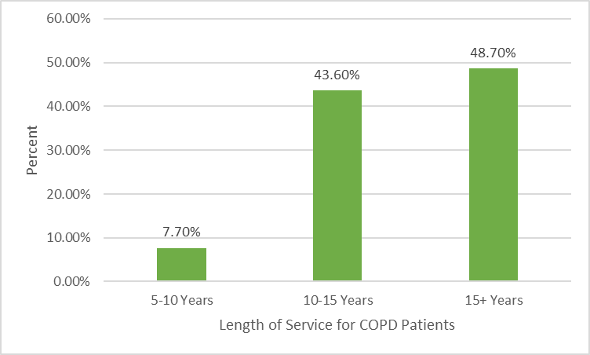
Fig. 2: Distribution of service length of the respondents (n=78)

Fig 2 represents the percentage of the workers of different service length who were only obstruction (NR). Among the different groups, the highest number of workers 48.7% has a service length between 15+ years and smallest percentage of workers 7.7% has a service length about 5-10 years.

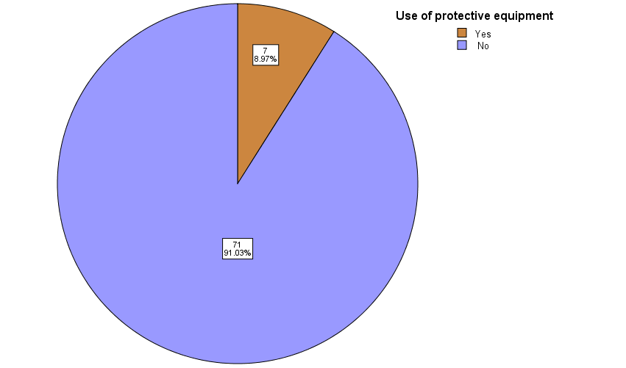
Fig. 3: Distribution of Protective equipment using among the respondents (n=78)

Fig 3 represents the percentage of the workers’ using protective equipment who were only obstruction (NR). Among users and non-users, the highest number of workers 91% (n=71) were non-users and smallest percentage of workers 13% (n=26) were non-users of protective equipment.

Table XV: Distribution of GOLD severity among the respondents (n=78)
Gold Severity Grade | Frequency | Percent
Mild (FEV1>80%) | 8 | 10.3
Moderate (FEV150-79%) | 46 | 59.0
Severe (FEV1 30-49) | 22 | 28.2
Very Severe (FEV1 <30) | 2 | 2.6
Total | 78 | 100

Among the 78 workers, 10.3% (n=8) were in mild and 59% (n=46) were moderate. Severe grade was in 28.2% (n=22) and 2.6% (n=2) of very severe grade.

Table XVI: Distribution of Service and Gold Severity (n=78)
GOLD Severity Grade | Working Length |  |  | p-value
GOLD Severity Grade | 5-10 | 10-15 | More than 15 | p-value
Mild | 0(0%) | 4(50%) | 4(50%) | 0.797
Moderate | 3(6.5%) | 22(47.8) | 21(45.7) | 0.797
Severe | 3(13.6%) | 7(31.8) | 12(54.5) | 0.797
Very Severe | 0(0%) | 1(50.0) | 1(50) | 0.797
Total | 6(7.7) | 34(43.6) | 38(48.7) | 0.797

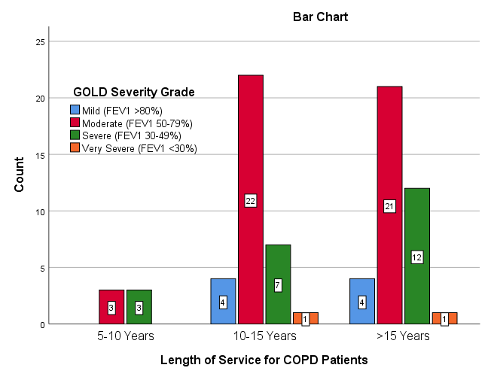
Fig. 4: Distribution of length of service and Gold Severity (n=78)

Table XVI & Fig 4 represents the percentage of gold severity with the different service length of the workers who were only obstruction (NR). Among the total mild workers, 50% (n=4) were more than 15 years of work length, none have mild severity whose working length were 0%. Among very severe grade, 50% (n=1) had service length between 10-15 years and 50% (n=1) were more than 15% of working length group.

In this section, we used both exposed (silica & smoking) and control (only smoking) respondents. Here, the total number of respondents was 206 (106 in exposed group and 100 in unexposed)

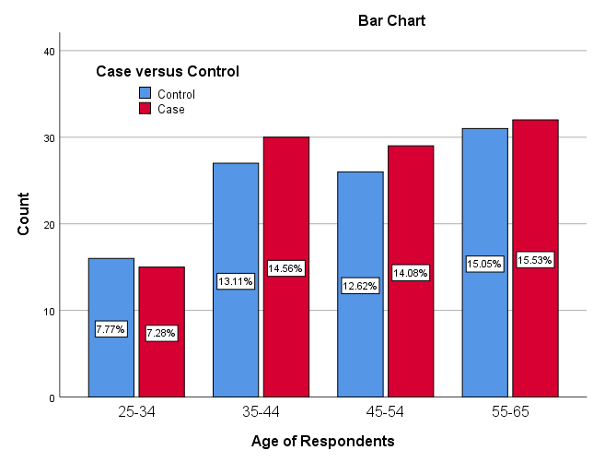
Fig. 5: Distribution of case and control among the different age group
Figure 5 shows the distribution of case and control among the different age group. We observed that the age distribution between case and control groups was approximately similar. For example, in age group 35-44, the percentage of cases was 14.56 and the percentage of control was 13.11.

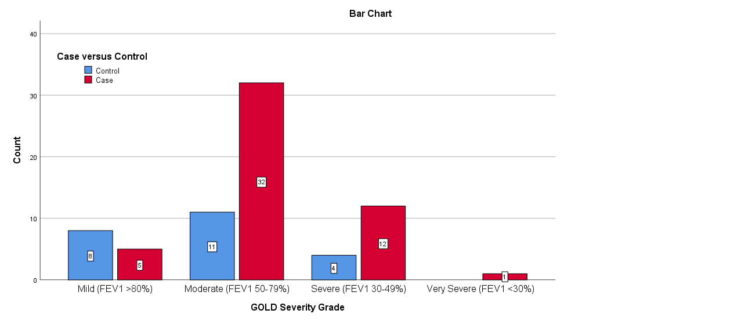
Fig. 6: Distribution of case and control among the different GOLD severity grade

Figure 6 shows the Distribution of case and control among the different GOLD severity grade. Here we observed that the GOLD severity distribution between case and control groups was very much unequal. For example, in the moderate severity, the maximum number of cases (32) was observed. We also found that there is only one patient in very severity group.

Table XVIII: Distribution of respondents who were exposed both silica and smoking among the different types of pattern (n=106)
Pattern | Frequency | Percent
Obstruction (NR) | 50 | 47.2
Obstruction(R) | 4 | 3.8
Restriction | 19 | 17.9
Normal | 33 | 31.1
Total | 106 | 100

Among the 106 workers (smoker with silica dust worker), 47.2% (n=50) were in obstruction (NR) pattern and 31.1% (n=33) were in normal COPD pattern.

Table XVII: Association between Exposure to smoking plus Silica (vs Smoking) and COPD (Logistic regression analysis)
Exposure | COPD |  |  | OR | 95% CI | P-value
Exposure | No | Yes | Total | OR | 95% CI | P-value
Smoker & Silica exposure | 56 (42.1) | 50 (68.5) | 106 | 2.99 | [1.64-5.46] | <0.001
Smoker | 77 (57.9) | 23 (31.5) | 100 | Ref. | - | <0.001
OR: Odds Ratio; CI: Confidence Interval

Table XVII present odds ratios and 95% confidence intervals (CI) for COPD different exposure. The logistic regression analysis shows that workers who were smoker and worked in silica dust were significantly (p<0.001) more likely to effected by COPD (OR 2.99; 95% CI 1.64–5.46) compared to the only smoker workers.

DISCUSSION
In this thesis, we assessed the association between silica dust exposure and COPD among the stone quarry workers versus control subjects in Sylhet. Here we established the diagnosis of COPD by compatible history and spirometry. We also assessed the prevalence of COPD among the smokers exposed to silica dust. Moreover, we analysed data using different GOLD severity scales of COPD.
We found the highest number of workers were belong to the 55-65 years of age. However, those suffering from COPD were found to be in the elderly group (>40 years). Among the cases subjects (n=200), about 65.5% were male and 53% were smoker and the association between sex of the respondents and smoking was statistically significant (p<0.001). A prevalence study conducted in Bangladesh also found that gender (male) was an important contributing factor to COPD (R. R. Biswas and Chowdhury 2017). Among 78 workers, 59% smoked greater than 10 pack cigarette per year. Out of 200 cases, 78 (Obstruction (NR) only) developed the COPD and among them, 64.1% were smoker. A study showed that the combination of smoking and occupational exposure was associated with a nearly five-fold increase in the risk of COPD (De Meer et al. 2004). Another study has also found interaction effects between smoking and occupational exposure for the risk of chronic bronchitis or chronic bronchitis plus airway obstruction (GOLD stage II or greater) (Boggia et al. 2008). Moreover, out of 100 control all were smoker and among them 23 developed the COPD. We observed 59% has a service length between 5-10 years and smallest percentage (19.5%) has a service length about 15+ years. Only 13% of workers users of protective equipment during their work. Most of the workers (75.5%) were belong to normal BMI category. Around 50%, 28.5%, and 47.5% worker have problem of cough, sputum production, and breathlessness problem during the data collection, respectively.
However, it is also possible that other COPD risk factors such as exposure to environmental or occupational air pollutants contribute to the relationship between social class and COPD in smokers (Hajat, Hsia, and O’Neill 2015).
Many aspects of the relationship between COPD and occupational exposures await further investigation. Some findings, including those from our group, suggest that prior occupational exposures may not only be associated with COPD, but may also carry a risk of more severe disease once established (P. D. Blanc et al. 2004). This potential effect, however, remains to be explored more fully. In this study of an urban population, lower socioeconomic circumstances such as low occupational status and low income were significantly associated with an increased risk of COPD. The relationships remained significant after adjustments for lifestyle and biological factors including smoking status. This relationship was mainly observed in smokers and no significant relationship between socioeconomic circumstances and COPD was found in those who never smoked.

Conclusion
The low level of published research on COPD has posed a major challenge to policymakers and many stakeholders, as there are not yet enough evidenced-based findings that can contribute to informed policy making to tackle this disease burden (Laraqui et al. 2000). It has been suggested that the low research output reflects the poor recent availability of research funding for COPD by funding agencies, which in turn reflects their lack of priority given to COPD (Abdool-Gaffar et al. 2011). It is also similar in Sylhet as well as Bangladesh. The data on COPD in Sylhet is limited, with the few published studies only available from some cities in Bangladesh. However, it is evident from those studies that the burden of COPD on dust workers in Bangladesh is significant. With continued urbanization, rapid ageing and lack of corresponding measures to check the effects on the population, the burden of COPD will continue to grow and it is set to become one of the major public health problems in Bangladesh.
There is need for more research on COPD prevalence, incidence, sequelae and mortality, along with well-designed trials, to identify how to effectively reduce risks from exposure to biomass fuels and tobacco smoking. With improved awareness of this problem, policy makers and governments of many African nations should give more attention to NCDs such as COPD, fund relevant research to improve evidence for decision making, and thus make informed decisions on preventive and treatment strategy options, and so help counter the rising disease burden over the next decade.
******* this section will be removed after completion of discussion
Fig 2 represents the percentage of the workers of different service length who were only obstruction (NR). Among the different groups, the highest number of workers 48.7% has a service length between 15+ years and smallest percentage of workers 7.7% has a service length about 5-10 years.
Fig 3 represents the percentage of the workers’ using protective equipment who were only obstruction (NR). Among users and non-users, the highest number of workers 91% (n=71) were non-users and smallest percentage of workers 13% (n=26) were non-users of protective equipment.
Among the 78 workers, 10.3% (n=8) were in mild and 59% (n=46) were moderate. Severe grade was in 28.2% (n=22) and 2.6% (n=2) of very severe grade.
Table XVI & Fig 4 represents the percentage of gold severity with the different service length of the workers who were only obstruction (NR). Among the total mild workers, 50% (n=4) were more than 15 years of work length, none have mild severity whose working length were 0%. Among very severe grade, 50% (n=1) had service length between 10-15 years and 50% (n=1) were more than 15% of working length group.
Figure 5 shows the distribution of case and control among the different age group. We observed that the age distribution between case and control groups was approximately similar. For example, in age group 35-44, the percentage of cases was 14.56 and the percentage of control was 13.11.
Figure 6 shows the Distribution of case and control among the different GOLD severity grade. Here we observed that the GOLD severity distribution between case and control groups was very much unequal. For example, in the moderate severity, the maximum number of cases (32) was observed. We also found that there is only one patient in very severity group.
Among the 106 workers (smoker with silica dust worker), 47.2% (n=50) were in obstruction (NR) pattern and 31.1% (n=33) were in normal COPD pattern.
Table XVII present odds ratios and 95% confidence intervals (CI) for COPD different exposure. The logistic regression analysis shows that workers who were smoker and worked in silica dust were significantly (p<0.001) more likely to effected by COPD (OR 2.99; 95% CI 1.64–5.46) compared to the only smoker workers.

References
Abdool-Gaffar, M. S. et al. 2011. “Guideline for the Management of Chronic Obstructive Pulmonary Disease--2011 Update.” South African medical journal = Suid-Afrikaanse tydskrif vir geneeskunde 101(1 Pt 2): 63–73.
Adeloye, Davies et al. 2015. “An Estimate of the Prevalence of COPD in Africa: A Systematic Analysis.” COPD: Journal of Chronic Obstructive Pulmonary Disease 12(1): 71–81.
Afonso, Ana S.M., Katia M.C. Verhamme, Miriam C.J.M. Sturkenboom, and Guy G.O. Brusselle. 2011. “COPD in the General Population: Prevalence, Incidence and Survival.” Respiratory Medicine 105(12): 1872–84.
Agarwal, Amit R., Fei Yin, and Enrique Cadenas. 2014. “Short-Term Cigarette Smoke Exposure Leads to Metabolic Alterations in Lung Alveolar Cells.” American Journal of Respiratory Cell and Molecular Biology 51(2): 284–93. http://www.ncbi.nlm.nih.gov/pubmed/24625219 (February 18, 2020).
Agustí, A. G.N. et al. 2003. “Systemic Effects of Chronic Obstructive Pulmonary Disease.” European Respiratory Journal 21(2): 347–60. http://www.ncbi.nlm.nih.gov/pubmed/12608452 (February 18, 2020).
Aït-Khaled, Nadia, Donald Enarson, and Jean Bousquet. 2001. “Chronic Respiratory Diseases in Developing Countries: The Burden and Strategies for Prevention and Management.” Bulletin of the World Health Organization 79(10): 971–79.
Alam, Dewan S. et al. 2015. “Prevalence and Determinants of Chronic Obstructive Pulmonary Disease (COPD) in Bangladesh.” COPD: Journal of Chronic Obstructive Pulmonary Disease 12(6): 658–67.
Alim, Md Abdul et al. 2014. “Respiratory Involvements among Women Exposed to the Smoke of Traditional Biomass Fuel and Gas Fuel in a District of Bangladesh.” Environmental Health and Preventive Medicine 19(2): 126–34.
Ameille, J., J. C. Dalphin, A. Descatha, and J. C. Pairon. 2006. “La Bronchopneumopathie Chronique Obstructive Professionnelle: Une Maladie Méconnue.” Revue des Maladies Respiratoires 23(SUPPL. 4). https://www.em-consulte.com/rmr/article/146313 (January 21, 2020).
“American Thoracic Society Statement: Occupational Contribution to the Burden of Airway Disease.” 2003. American Journal of Respiratory and Critical Care Medicine 167(5): 787–97.
Angelis, Nikolaos et al. 2014. “Airway Inflammation in Chronic Obstructive Pulmonary Disease.” Journal of Thoracic Disease 6(SUPPL1): S167.
Atsou, Kokuvi, Christos Chouaid, and Gilles Hejblum. 2011. “Variability of the Chronic Obstructive Pulmonary Disease Key Epidemiological Data in Europe: Systematic Review.” BMC Medicine 9(1): 7. http://bmcmedicine.biomedcentral.com/articles/10.1186/1741-7015-9-7 (January 21, 2020).
Balmes, John R. 2010. “When Smoke Gets in Your Lungs.” In Proceedings of the American Thoracic Society, , 98–101.
Barnes, Peter J. 2012. “Chronic Obstructive Pulmonary Disease (COPD).” In Chemical Biology: Approaches to Drug Discovery and Development to Targeting Disease, , 245–65. https://www.who.int/news-room/fact-sheets/detail/chronic-obstructive-pulmonary-disease-(copd) (January 21, 2020).
Barr, R Graham, Julie Herbstman, Frank E Speizer, and Carlos A Camargo. 2002. “Validation of Self-Reported Chronic Obstructive Pulmonary Disease in a Cohort Study of Nurses.” American journal of epidemiology 155(10): 965–71. http://www.ncbi.nlm.nih.gov/pubmed/11994237 (February 21, 2020).
Benfield, Thomas, Peter Lange, and Jørgen Vestbo. 2008. “COPD Stage and Risk of Hospitalization for Infectious Disease.” Chest 134(1): 46–53. http://www.ncbi.nlm.nih.gov/pubmed/18403661 (February 21, 2020).
Bernardo, Ivan, Steven Bozinovski, and Ross Vlahos. 2015. “Targeting Oxidant-Dependent Mechanisms for the Treatment of COPD and Its Comorbidities.” Pharmacology and Therapeutics 155: 60–79. http://www.ncbi.nlm.nih.gov/pubmed/26297673 (February 18, 2020).
Biswas, Rajat Sanker Roy et al. 2016. “Indoor Biomass Fuel Smoke Exposure as a Risk Factor for Chronic Obstructive Pulmonary Disease (COPD) for Women of Rural Bangladesh.” Chattagram Maa-O-Shishu Hospital Medical College Journal 15(1): 8–11.
Biswas, RajatS.R., and FazleeK Chowdhury. 2017. “Risk Factors of Chronic Obstructive Pulmonary Disease among Rural Women, Chittagong, Bangladesh.” Egyptian Journal of Bronchology 11(3): 188. http://www.ejbronchology.eg.net/text.asp?2017/11/3/188/211395 (January 21, 2020).
Blanc, P. D. et al. 2004. “The Association between Occupational Factors and Adverse Health Outcomes in Chronic Obstructive Pulmonary Disease.” Occupational and Environmental Medicine 61(8): 661–67.
Blanc, P. D., A. M.B. Menezes, et al. 2009. “Occupational Exposures and COPD: An Ecological Analysis of International Data.” European Respiratory Journal 33(2): 298–304. http://www.ncbi.nlm.nih.gov/pubmed/19010980 (February 21, 2020).
Blanc, P. D., C. Iribarren, et al. 2009. “Occupational Exposures and the Risk of COPD: Dusty Trades Revisited.” Thorax 64(1): 6–12.
Blanc, Paul D. 2012. “Occupation and COPD: A Brief Review.” In Journal of Asthma, , 2–4.
Blanco, Ignacio et al. 2018. “Geographical Distribution of COPD Prevalence in Europe, Estimated by an Inverse Distance Weighting Interpolation Technique.” International Journal of COPD 13: 57–67.
Blum, Arnon, Claudia Simsolo, Rizak Sirchan, and Samah Haiek. 2011. “‘Obesity Paradox’ in Chronic Obstructive Pulmonary Disease.” Israel Medical Association Journal 13(11): 672–75. https://www.researchgate.net/publication/221779720_Obesity_Paradox_in_Chronic_Obstructive_Pulmonary_Disease (February 21, 2020).
Boggia, Bartolomeo et al. 2008. “Burden of Smoking and Occupational Exposure on Etiology of Chronic Obstructive Pulmonary Disease in Workers of Southern Italy.” Journal of Occupational and Environmental Medicine 50(3): 366–70.
Borné, Yan, Wafa Ashraf, Suneela Zaigham, and Sophia Frantz. 2019. “Socioeconomic Circumstances and Incidence of Chronic Obstructive Pulmonary Disease (COPD) in an Urban Population in Sweden.” COPD: Journal of Chronic Obstructive Pulmonary Disease 16(1): 51–57. https://www.tandfonline.com/doi/full/10.1080/15412555.2019.1582618 (January 22, 2020).
Boukhenouna, Samia, Mark A. Wilson, Karim Bahmed, and Beata Kosmider. 2018. “Reactive Oxygen Species in Chronic Obstructive Pulmonary Disease.” Oxidative Medicine and Cellular Longevity 2018.
Cabrera López, Carlos et al. 2014. “Prevalence of Chronic Obstructive Pulmonary Disease in the Canary Islands.” Archivos de Bronconeumología (English Edition) 50(7): 272–77.
Capistrano, Sarah J., David van Reyk, Hui Chen, and Brian G. Oliver. 2017. “Evidence of Biomass Smoke Exposure as a Causative Factor for the Development of COPD.” Toxics 5(4).
Carey, Renee N. et al. 2014. “Estimated Prevalence of Exposure to Occupational Carcinogens in Australia (2011-2012).” Occupational and Environmental Medicine 71(1): 55–62. http://www.ncbi.nlm.nih.gov/pubmed/24158310 (February 21, 2020).
Cazzola, Mario et al. 2011. “The Prevalence of Asthma and COPD in Italy: A Practice-Based Study.” Respiratory Medicine 105(3): 386–91.
Celli, B. R. et al. 1995. “Standards for the Diagnosis and Care of Patients with Chronic Obstructive Pulmonary Disease.” American Journal of Respiratory and Critical Care Medicine 152(5 II).
Ciapponi, Agustín et al. 2014. “The Epidemiology and Burden of COPD in Latin America and the Caribbean: Systematic Review and Meta-Analysis.” COPD: Journal of Chronic Obstructive Pulmonary Disease 11(3): 339–50.
Cruickshank-Quinn, Charmion I. et al. 2018. “Metabolomics and Transcriptomics Pathway Approach Reveals Outcome-Specific Perturbations in COPD.” Scientific Reports 8(1): 17132. http://www.ncbi.nlm.nih.gov/pubmed/30459441 (February 18, 2020).
“Definition and Classification of Chronic Bronchitis for Clinical and Epidemiological Purposes. A Report to the Medical Research Council by Their Committee on the Aetiology of Chronic Bronchitis.” 1965. Lancet (London, England) 1(7389): 775–79. http://www.ncbi.nlm.nih.gov/pubmed/4165081 (January 21, 2020).
Dement, John et al. 2015. “A Case-Control Study of Airways Obstruction among Construction Workers.” American Journal of Industrial Medicine 58(10): 1083–97. http://www.ncbi.nlm.nih.gov/pubmed/26123003 (February 18, 2020).
Dement, John M. et al. 2010. “Airways Obstruction among Older Construction and Trade Workers at Department of Energy Nuclear Sites.” American Journal of Industrial Medicine 53(3): 224–40. http://www.ncbi.nlm.nih.gov/pubmed/20025074 (February 21, 2020).
Dhadke, Vithal N, Shubhangi V Dhadke, and Nikhil Raut. 2015. “Clinical Profile in Chronic Obstructive Pulmonary Disease Patients and Their Evaluation with Spirometry and 2D Echo.” International Journal of Current Research 7(2): 12480–88. http://www.journalcra.com/article/clinical-profile-chronic-obstructive-pulmonary-disease-patients-and-their-evaluation (February 21, 2020).
Domej, Wolfgang, Karl Oettl, and Wilfried Renner. 2014. “Oxidative Stress and Free Radicals in COPD-Implications and Relevance for Treatment.” International Journal of COPD 9: 1207–24.
Van Eeden, Stephan F., and Don D. Sin. 2013. “Oxidative Stress in Chronic Obstructive Pulmonary Disease: A Lung and Systemic Process.” Canadian Respiratory Journal 20(1): 27–29.
Eisner, Mark D. et al. 2010. “An Official American Thoracic Society Public Policy Statement: Novel Risk Factors and the Global Burden of Chronic Obstructive Pulmonary Disease.” American Journal of Respiratory and Critical Care Medicine 182(5): 693–718.
Ezzati, Majid, Alan D Lopez, Anthony Rodgers, and Christopher J L Murray. 2004. Comparative Quantification of Health Risks.
Fabricius, Peder et al. 2011. “Prevalence of COPD in Copenhagen.” Respiratory Medicine 105(3): 410–17.
Fell, Anne Kristin M., Liv Ingunn B. Sikkeland, Martin Veel Svendsen, and Johny Kongerud. 2010. “Airway Inflammation in Cement Production Workers.” Occupational and Environmental Medicine 67(6): 395–400. http://www.ncbi.nlm.nih.gov/pubmed/19854695 (February 21, 2020).
Finney, L. J. et al. 2013. “Chronic Obstructive Pulmonary Disease in Sub-Saharan Africa: A Systematic Review.” International Journal of Tuberculosis and Lung Disease 17(5): 583–89.
Fletcher, C. M., and N. B. Pride. 1984. “Definitions of Emphysema, Chronic Bronchitis, Asthma, and Airflow Obstruction: 25 Years on from the Ciba Symposium.” Thorax 39(2): 81–85.
García-Lucio, Jéssica et al. 2018. “Imbalance between Endothelial Damage and Repair Capacity in Chronic Obstructive Pulmonary Disease” ed. Antonino Di Stefano. PLOS ONE 13(4): e0195724. https://dx.plos.org/10.1371/journal.pone.0195724 (February 18, 2020).
Van Gemert, Frederik et al. 2015. “Prevalence of Chronic Obstructive Pulmonary Disease and Associated Risk Factors in Uganda (FRESH AIR Uganda): A Prospective Cross-Sectional Observational Study.” The Lancet Global Health 3(1): e44–51.
Gibson, G. John, Robert Loddenkemper, Bo Lundbäck, and Yves Sibille. 2013. “Respiratory Health and Disease in Europe: The New European Lung White Book.” European Respiratory Journal 42(3): 559–63.
GOLD. 2019. Global Initiative for Chronic Obstructive L Ung D Isease. www.goldcopd.org (February 21, 2020).
Gómez Sáenz, J. T. et al. 2014. “Enfermedad Pulmonar Obstructiva Crónica: Morbimortalidad e Impacto Sanitario.” Semergen 40(4): 198–204.
Govender, Nadira, Umesh G. Lalloo, and Rajen N. Naidoo. 2011. “Occupational Exposures and Chronic Obstructive Pulmonary Disease: A Hospital Based Case - Control Study.” Thorax 66(7): 597–601.
Grigsby, Matthew et al. 2016. “Socioeconomic Status and COPD among Low-and Middle-Income Countries.” International Journal of COPD 11(1): 2497–2507.
Hajat, Anjum, Charlene Hsia, and Marie S. O’Neill. 2015. “Socioeconomic Disparities and Air Pollution Exposure: A Global Review.” Current environmental health reports 2(4): 440–50.
Harber, Philip et al. 2007. “Effect of Occupational Exposures on Decline of Lung Function in Early Chronic Obstructive Pulmonary Disease.” American Journal of Respiratory and Critical Care Medicine 176(10): 994–1000.
Hart, J. E. et al. 2009. “Chronic Obstructive Pulmonary Disease Mortality Ir Railroad Workers.” Occupational and Environmental Medicine 66(4): 221–26.
Helvaci, Mehmet Rami, Leyla Yilmaz Aydin, and Yusuf Aydin. 2012. “Chronic Obstructive Pulmonary Disease May Be One of the Terminal End Points of Metabolic Syndrome.” Pakistan Journal of Medical Sciences 28(3): 376–79. www.pjms.com.pk (February 21, 2020).
Hiemstra, Pieter S., Paul B. McCray, and Robert Bals. 2015. “The Innate Immune Function of Airway Epithelial Cells in Inflammatory Lung Disease.” European Respiratory Journal 45(4): 1150–62.
Hnizdo, E., E. Baskind, and G. K. Sluis-Cremer. 1990. “Combined Effect of Silica Dust Exposure and Tobacco Smoking on the Prevalence of Respiratory Impairments among Gold Miners.” Scandinavian Journal of Work, Environment and Health 16(6): 411–22.
Hnizdo, E., and V. Vallyathan. 2003. “Chronic Obstructive Pulmonary Disease Due to Occupational Exposure to Silica Dust: A Review of Epidemiological and Pathological Evidence.” Occupational and Environmental Medicine 60(4): 237–43.
Hnizdo, Eva, Patricia A. Sullivan, Ki Moon Bang, and Gregory Wagner. 2002. “Association between Chronic Obstructive Pulmonary Disease and Employment by Industry and Occupation in the US Population: A Study of Data from the Third National Health and Nutrition Examination Survey.” American Journal of Epidemiology 156(8): 738–46.
Hooper, Richard et al. 2012. “Risk Factors for COPD Spirometrically Defined from the Lower Limit of Normal in the BOLD Project.” European Respiratory Journal 39(6): 1343–53.
Hu, Guoping et al. 2010. “Risk of COPD from Exposure to Biomass Smoke: A Metaanalysis.” Chest 138(1): 20–31.
Iftikhar, Bushra et al. 2009. “Relationship Between Silica Dust Exposure and Chronic Obstructive Pulmonary Disease in Workers of Dust Generating Industries of District Peshawar.” 7(1).
Irwig, L. M., and P. Rocks. 1978. “Lung Function and Respiratory Symptoms in Silicotic and Nonsilicotic Gold Miners.” American Review of Respiratory Disease 117(3): 429–35.
Islam, M. S. et al. 2013. “Prevalence and Risk Factors of Chronic Obstructive Pulmonary Disease (COPD) in Dhaka City Population.” Mymensingh medical journal : MMJ 22(3): 547–51.
Jordan, Rachel E., Kar Keung Cheng, Martin R. Miller, and Peymané Adab. 2011. “Passive Smoking and Chronic Obstructive Pulmonary Disease: Cross-Sectional Analysis of Data from the Health Survey for England.” BMJ Open 1(2).
Kanervisto, Merja et al. 2011. “Low Socioeconomic Status Is Associated with Chronic Obstructive Airway Diseases.” Respiratory Medicine 105(8): 1140–46.
Kim, Victor, and Gerard J. Criner. 2013. “Chronic Bronchitis and Chronic Obstructive Pulmonary Disease.” American Journal of Respiratory and Critical Care Medicine 187(3): 228–37.
Kirkham, Paul A., and Peter J. Barnes. 2013. “Oxidative Stress in COPD.” Chest 144(1): 266–73.
Koeverden, Ian Van, Paul D. Blanc, Russell P. Bowler, and Mehrdad Arjomandi. 2015. “Secondhand Tobacco Smoke and COPD Risk in Smokers: A COPDGene Study Cohort Subgroup Analysis.” COPD: Journal of Chronic Obstructive Pulmonary Disease 12(2): 182–89.
Kubo, Hiroaki et al. 2019. “Exercise Ameliorates Emphysema of Cigarette Smoke-Induced COPD in Mice through the Exercise-Irisin-Nrf2 Axis.” International Journal of COPD 14: 2507–16.
Kurmi, Om P. et al. 2010. “COPD and Chronic Bronchitis Risk of Indoor Air Pollution from Solid Fuel: A Systematic Review and Meta-Analysis.” Thorax 65(3): 221–28.
Lahousse, Lies et al. 2017. “Epidemiology and Impact of Chronic Bronchitis in Chronic Obstructive Pulmonary Disease.” European Respiratory Journal 50(2).
Lai, Hanpeng et al. 2018. “Combined Effect of Silica Dust Exposure and Cigarette Smoking on Total and Cause-Specific Mortality in Iron Miners: A Cohort Study.” Environmental Health: A Global Access Science Source 17(1): 46. https://ehjournal.biomedcentral.com/articles/10.1186/s12940-018-0391-0 (February 18, 2020).
Lamprecht, Bernd et al. 2011. “COPD in Never Smokers: Results from the Population-Based Burden of Obstructive Lung Disease Study.” Chest 139(4): 752–63. http://www.ncbi.nlm.nih.gov/pubmed/20884729 (February 18, 2020).
Laraqui, C. H. et al. 2000. “Prevalence of Respiratory Symptoms in Traditional Grain Market Workers in Casablanca and Assessment of Sensitivization Levels.” Revue des Maladies Respiratoires 17(5): 947–55. https://www.researchgate.net/publication/285271874_Prevalence_of_respiratory_symptoms_in_traditional_grain_market_workers_in_Casablanca_and_assessment_of_sensitivization_levels (February 7, 2020).
Lerner, Chad A., Isaac K. Sundar, and Irfan Rahman. 2016. “Mitochondrial Redox System, Dynamics, and Dysfunction in Lung Inflammaging and COPD.” International Journal of Biochemistry and Cell Biology 81(Pt B): 294–306.
Louhelainen, Noora et al. 2009. “Persistence of Oxidant and Protease Burden in the Airways after Smoking Cessation.” BMC Pulmonary Medicine 9(1): 25. https://bmcpulmmed.biomedcentral.com/articles/10.1186/1471-2466-9-25 (February 18, 2020).
Lozano, Rafael et al. 2012. “Global and Regional Mortality from 235 Causes of Death for 20 Age Groups in 1990 and 2010: A Systematic Analysis for the Global Burden of Disease Study 2010.” The Lancet 380(9859): 2095–2128.
Madhurmay et al. 2019. “Study of Association between Exposure to Indoor Air Pollution and Chronic Obstructive Pulmonary Disease among Nonsmokers in a North Indian Population – A Case–Control Study.” Indian Journal of Respiratory Care 8(2): 71.
Mahfuz, Mustafa, Tahmeed Ahmed, Sk. Akhtar Ahmad, and Manzurul Haque Khan. 2014. “Altered Pulmonary Function among the Transport Workers in Dhaka City.” Health 06(16): 2144–53.
Mannino, David M. et al. 2002. “Chronic Obstructive Pulmonary Disease Surveillance--United States, 1971-2000.” Respiratory care 47(10): 1184–99.
De Marco, Roberto et al. 2011. “Risk Factors for Chronic Obstructive Pulmonary Disease in a European Cohort of Young Adults.” American Journal of Respiratory and Critical Care Medicine 183(7): 891–97.
De Matteis, Sara et al. 2016. “Occupations Associated with COPD Risk in the Large Population-Based UK Biobank Cohort Study.” Occupational and Environmental Medicine 73(6): 378–84.
Mazitova, Nailya N., Anatoly A. Saveliev, Zuhra M. Berheeva, and Nail Kh Amirov. 2012. “COPD and Occupation: A Retrospective Cohort Study of Industrial Workers.” Arhiv za Higijenu Rada i Toksikologiju 63(3): 345–56.
McGuinness, Adam, and Elizabeth Sapey. 2017. “Oxidative Stress in COPD: Sources, Markers, and Potential Mechanisms.” Journal of Clinical Medicine 6(2): 21.
De Meer, Gea et al. 2004. “Interaction of Atopy and Smoking on Respiratory Effects of Occupational Dust Exposure: A General Population-Based Study.” Environmental Health: A Global Access Science Source 3.
Meijer, E., H. Kromhout, and D. Heederik. 2001. “Respiratory Effects of Exposure to Low Levels of Concrete Dust Containing Crystalline Silica.” American Journal of Industrial Medicine 40(2): 133–40.
Menezes, Ana Maria B. et al. 2005. “Chronic Obstructive Pulmonary Disease in Five Latin American Cities (the PLATINO Study): A Prevalence Study.” Lancet 366(9500): 1875–81.
Mirza, Shireen, Ryan D. Clay, Matthew A. Koslow, and Paul D. Scanlon. 2018. “COPD Guidelines: A Review of the 2018 GOLD Report.” Mayo Clinic Proceedings 93(10): 1488–1502. http://www.ncbi.nlm.nih.gov/pubmed/30286833 (February 18, 2020).
Mitzner, Wayne. 2011. “Emphysema - A Disease of Small Airways or Lung Parenchyma?” New England Journal of Medicine 365(17): 1637–39.
Ni, Lei, Chia Chen Chuang, and Li Zuo. 2015. “Fine Particulate Matter in Acute Exacerbation of COPD.” Frontiers in Physiology 6(OCT).
Ocakli, Birsen et al. 2018. “The Impact of Exposure to Biomass Smoke versus Cigarette Smoke on Inflammatory Markers and Pulmonary Function Parameters in Patients with Chronic Respiratory Failure.” International Journal of COPD 13: 1261–67.
Paulin, Laura M. et al. 2015. “Occupational Exposures Are Associated with Worse Morbidity in Patients with Chronic Obstructive Pulmonary Disease.” American Journal of Respiratory and Critical Care Medicine 191(5): 557–65.
Raherison, C., and P. O. Girodet. 2009. “Epidemiology of COPD.” European Respiratory Review 18(114): 213–21.
Ralston, Stuart et al. 2018. Davidson’s Principles and Practice of Medicine.
Reid, Lynne. 1967. The Pathology of Emphysema. Chicago: Year Book Medical Publishers.
Rennard, S. et al. 2002. “Impact of COPD in North America and Europe in 2000: Subjects’ Perspective of Confronting COPD International Survey.” European Respiratory Journal 20(4): 799–805. http://www.ncbi.nlm.nih.gov/pubmed/12412667 (February 18, 2020).
Rennard, Stephen I., and M. Bradley Drummond. 2015. “Early Chronic Obstructive Pulmonary Disease: Definition, Assessment, and Prevention.” The Lancet 385(9979): 1778–88. http://www.ncbi.nlm.nih.gov/pubmed/25943942 (February 18, 2020).
Reynolds, C J et al. 2017. “Chronic Obstructive Pulmonary Disease in Welsh Slate Miners.” Occupational medicine (Oxford, England) 67(1): 20–25. http://www.ncbi.nlm.nih.gov/pubmed/27816911 (February 21, 2020).
Robinson, J., R. Tuder, and J. Hunt. 2013. “Alpha-1 Antitrypsin and the Pathogenesis of Emphysema.” Minerva Pneumologica 52(4): 137–47. https://www.researchgate.net/publication/259367798_Alpha-1_antitrypsin_and_the_pathogenesis_of_emphysema (February 18, 2020).
Rushton, Lesley. 2007. “Chronic Obstructive Pulmonary Disease and Occupational Exposure to Silica.” Reviews on Environmental Health 22(4): 255–72.
Rycroft, Catherine E., Anne Heyes, Lee Lanza, and Karin Becker. 2012. “Epidemiology of Chronic Obstructive Pulmonary Disease: A Literature Review.” International Journal of COPD 7: 457–94.
Salvi, Sundeep, and Peter J. Barnes. 2010. “Is Exposure to Biomass Smoke the Biggest Risk Factor for COPD Globally?” Chest 138(1): 3–6.
Salvi, Sundeep S., and Peter J. Barnes. 2009. “Chronic Obstructive Pulmonary Disease in Non-Smokers.” The Lancet 374(9691): 733–43.
Saroar Hosan, Md, Md Shariful Islam, Tawfiqa Rahman, and Md Asif Hassan. 2017. Prevalence of Bangladeshi Patient’s in COPD Disorder. www.ijipsr.com (February 18, 2020).
Seaton, Anthony, Douglas Seaton, and A. Gordon Leitch. 2008. 1–2 Crofton and Douglas’s Respiratory Diseases: Fifth Edition Crofton and Douglas’s Respiratory Diseases: Fifth Edition.
Smith, Jaclyn, and Ashley Woodcock. 2006. “Cough and Its Importance in COPD.” International journal of chronic obstructive pulmonary disease 1(3): 305–14.
Soriano, Joan B., and Roberto Rodríguez-Roisin. 2011. “Chronic Obstructive Pulmonary Disease Overview: Epidemiology, Risk Factors, and Clinical Presentation.” In Proceedings of the American Thoracic Society, , 363–67. http://www.ncbi.nlm.nih.gov/pubmed/21816993 (February 18, 2020).
Steenland, Kyle, and David Brown. 1995. “Mortality Study of Gold Miners Exposed to Silica and Nonasbestiform Amphibole Minerals: An Update with 14 More Years of Follow‐up.” American Journal of Industrial Medicine 27(2): 217–29.
Sutradhar, Ipsita et al. 2019. “Prevalence and Risk Factors of Chronic Obstructive Pulmonary Disease in Bangladesh: A Systematic Review.” Cureus.
Tageldin, Mohamed Awad et al. 2012. “Distribution of COPD-Related Symptoms in the Middle East and North Africa: Results of the BREATHE Study.” Respiratory Medicine 106(SUPPL. 2).
Tan, Wan C., and Tze P. Ng. 2008. “COPD in Asia: Where East Meets West.” Chest 133(2): 517–27. http://www.ncbi.nlm.nih.gov/pubmed/18252918 (February 18, 2020).
Telenga, Eef D. et al. 2014. “Untargeted Lipidomic Analysis in Chronic Obstructive Pulmonary Disease Uncovering Sphingolipids.” American Journal of Respiratory and Critical Care Medicine 190(2): 155–64. http://www.ncbi.nlm.nih.gov/pubmed/24871890 (February 18, 2020).
Tilert, Timothy et al. 2013. “Estimating the U.S. Prevalence of Chronic Obstructive Pulmonary Disease Using Pre- and Post-Bronchodilator Spirometry: The National Health and Nutrition Examination Survey (NHANES) 2007-2010.” Respiratory Research 14(1).
Torén, Kjell, and Bengt Järvholm. 2014. “Effect of Occupational Exposure to Vapors, Gases, Dusts, and Fumes on Copd Mortality Risk among Swedish Construction Workers.” Chest 145(5): 992–97. http://www.ncbi.nlm.nih.gov/pubmed/24264472 (February 21, 2020).
Torres-Durán, María et al. 2018. “Alpha-1 Antitrypsin Deficiency: Outstanding Questions and Future Directions.” Orphanet Journal of Rare Diseases 13(1): 114. http://www.ncbi.nlm.nih.gov/pubmed/29996870 (February 18, 2020).
Tse, L. A. et al. 2007. “Mortality from Non-Malignant Respiratory Diseases among People with Silicosis in Hong Kong: Exposure-Response Analyses for Exposure to Silica Dust.” Occupational and Environmental Medicine 64(2): 87–92. http://www.ncbi.nlm.nih.gov/pubmed/16973737 (February 21, 2020).
Vos, Theo et al. 2015. “Global, Regional, and National Incidence, Prevalence, and Years Lived with Disability for 301 Acute and Chronic Diseases and Injuries in 188 Countries, 1990-2013: A Systematic Analysis for the Global Burden of Disease Study 2013.” The Lancet 386(9995): 743–800.
Wang, Chen et al. 2018. “Prevalence and Risk Factors of Chronic Obstructive Pulmonary Disease in China (the China Pulmonary Health [CPH] Study): A National Cross-Sectional Study.” The Lancet 391(10131): 1706–17. http://www.ncbi.nlm.nih.gov/pubmed/29650248 (February 18, 2020).
Wang, Yujie et al. 2018. “Role of Inflammatory Cells in Airway Remodeling in COPD.” International Journal of COPD 13: 3341–48.
Wiles, F J, and M H Faure. 1975. “Chronic Obstructive Lung Disease in Gold Miners.” Inhaled particles 4 Pt 2: 727–35. http://www.ncbi.nlm.nih.gov/pubmed/1236246 (January 21, 2020).
Winberger, Steven E, Barbara Cockrill, and Jess Mandel. 2014. “Chronic Obstructive Pulmonary Disease | Principles of Pulmonary Medicine.” : 91–109. https://accessmedicine.mhmedical.com/content.aspx?bookid=1130&sectionid=79745089 (February 21, 2020).
Yacobi, Nazanin R. et al. 2011. “Nanomaterial Interactions with and Trafficking across the Lung Alveolar Epithelial Barrier: Implications for Health Effects of Air-Pollution Particles.” Air Quality, Atmosphere and Health 4(1): 65–78.
Yassin, Abdiaziz S., Francis Yebesi, and Rex Tingle. 2005. “Occupational Exposure to Crystalline Silica Dust in the United States, 1988-2003.” Environmental Health Perspectives 113(3): 255–60.
Yin, Peng et al. 2011. “Prevalence of COPD and Its Association with Socioeconomic Status in China: Findings from China Chronic Disease Risk Factor Surveillance 2007.” BMC Public Health 11(1): 586. http://bmcpublichealth.biomedcentral.com/articles/10.1186/1471-2458-11-586 (January 22, 2020).
Yue, Li, and Hongwei Yao. 2016. “Mitochondrial Dysfunction in Inflammatory Responses and Cellular Senescence: Pathogenesis and Pharmacological Targets for Chronic Lung Diseases.” British Journal of Pharmacology 173(15): 2305–18.
Al Zaabi, Ashraf et al. 2011. “Prevalence of COPD in Abu Dhabi, United Arab Emirates.” Respiratory Medicine 105(4): 566–70.

Appendix-1
Data collection sheet
SL.No : Date:
Name :
Age :
Sex : 1. Male 2. Female
Education : 1. Illiterate 2.Primary 3. Above
Socioeconomic condition:
Address :
Mobile No :
Smoking status: 1) smoker 2)nonsmoker
Duration of smoking: 1) 1-5 years 2) 6-10 years 3) 11-15 years 4) 16-20 years.
Stickes used per day: 1) 1-5 2) 5-10 3) 10-15.
Peak years:
Length of service: 1) 1-5 years 2) 6-10 years 3) 10-15 years 4) > 15 years
Working hours: 1) <8 hours 2) >8hours
Use of biomass fuel during cooking: 1. Yes 2. No
Is there any facility that you can avail if you fell
sick in your workplace ? 1. Yes 2.No
If yes, what it is?
Do you use any sort of protective equipment while working? 1. Yes 2. No
If yes, what are they?
Respiratory symptom:
- Cough:
Present/absent
Duration years
Dry/productive
2. Sputum production:
Do you bring up plegum for as much as 3 months in a year for 2 consecutive year? 1) yes 2) No
3. Breathlessness: MRC grading
0. No breathlessness except with streneous exercise
1. Are you troubled by shortness of breath when
hurrying on level ground or walking up a slight hill?
2. Do you get short of breath walking with
other people of your own age on level ground?
3. Do you have to stop for breath when
walking at your own pace on level ground?
4. Too breathless to leave the house or breathless when dressing
or undressing
Result of spirometry:
- FVC ( litres) 1) 2) 3) 3)
- FEV1 ( litres) 1) 2) 3) 3)
- FEV1/FVC ( from best of each) =

Classification of airflow limitation severity of COPD
(based on post bronchodilator FEV1) in patient with FEV1/FVC ratio <0.70.

 | FEV1% predicted | Severity | Stage
GOLD-1 | >80% | Mild | Stage-1
GOLD-2 | 50-79% | Moderate | Stage-2
GOLD-3 | 30-49% | Severe | Stage-3
GOLD-4 | <30% | Very severe | Stage-4

Appendix-2
Informed Written Consent (English):
Getting full information about the purpose, procedure and utility of this study, I give consent to participate in this study. I have not been influenced by anybody or groups or my fundamental human rights have not been violated due to participation in this study. I am assured that confidentiality of all gathered information will be maintained. This information will be used only for study purpose.
My participation in this study is entirely voluntary. I have right to withdraw my consent and discontinue participation at any time.
I will not get any remuneration due to participation in this study.
I am willingly giving signature to this consent form.

Signature of the participant/left thumb print

Signature of the witness/left thumb print Signature of the researcher with date
m¤§wZcÎ
এই গবেষণা কর্মের উদ্দেশ্য, পদ্বতি ও উপযোগিতা সম্পর্কে পূর্ণ ধারণা পেয়ে, আমি এতে অংশ গ্রহণের সম্মতি প্রদান করছি।গবেষণা কর্মে অংশ গ্রহণের জন্য আমি কোন ব্যক্তি বা গোষ্ঠীর দ্বারা প্রভাবিত হইনি অথবা আমার কোন মৌলিক মানবাধিকার ক্ষুন্ন হয়নি। আমি নিশ্চিত হয়েছি যে এই গবেষণা থেকে সংগৃহিত তথ্যাবলী সম্পুর্ণ গোপন রাখা হবে।এই তথ্যাদি কেবলমাত্র গবেষণার কাজেই ব্যবহার করা হবে।
এই গবেষণায় অংশগ্রহন সম্পুর্ন আমার ইচ্ছাধীন। আমি ইচ্ছা করলে গবেষণায় অংশ গ্রহণ না করতে পারি এবং যেকোন মুহুর্তে আমি আমার সম্মতি প্রত্যাহার করার অধিকার রাখি।
এই গবেষণায় অংশগ্রহনের জন্য আমি কোন সম্মানী প্রাপ্য হব না। আমি স্বেচ্চায় এই সম্মতিপত্রে স্বাক্ষর করছি।

অংশগ্রহণকারীর স্বাক্ষর/বাম বৃদ্ধাঙ্গুলির ছাপ

সাক্ষীর স্বাক্ষর/বাম বৃদ্ধাঙ্গুলির ছাপ গবেষকের স্বাক্ষর ওতারিখ

